OCCURRENCE AND ABUNDANCE OF RECRUTING JUVENILE ANGUILLID EELS IN THE SABAKI ESTUARY, ATHI RIVER, KENYA

LENA MUTHONI GITONGA

A thesis submitted in partial fulfilment of the requirements for the Degree of Master of Science in Fisheries of Pwani University

JANUARY, 2023

DECLARATION

By the Candidate:

I declare that this thesis is my original work and has not been presented at any University or Institution for the award of a degree or any other academic purpose.

Lena Muthoni Gitonga

SG25/PU/36065/19 Signature Date

By the Supervisors:

This research thesis has been submitted with our approval as the supervisors.

Prof. Mlewa Chrisestom Mwatete

Pwani University Signature Date

Dr. Thomas Mkare

Pwani University Signature Date

DEDICATION
This thesis is dedicated to my parents, David Gitonga and Eunice Gitonga, who have held my hand and walked with me throughout my study career. Their support has kept my faith alive!

ACKNOWLEDGEMENT
I thank my supervisors; Prof. Mlewa Chrisestom Mwatete and Dr. Thomas Mkare; for guidance and support from proposal development through to the writing of this thesis. I am very grateful to the academic input of Dr. Charles Kihia and Dr. Celine Hanzen who conceptualized and secured the project that funded my field and laboratory work. I also thank my field technicians; Mr. Roman Kazungu and Mr. Gira Mnyika Mbovu, for their assistance with the field work. I am grateful to the Western Indian Ocean Marine Sciences Association (WIOMSA) for funding my Master Degree program through the research project titled: ‘Slippery resource in peril: ecology of Western Indian Ocean Anguillid eels and their contribution to sustainable fisheries and livelihood along the east coast of Africa’, Kenya Marine and Fisheries Research Institute (KMFRI) for providing laboratory space and facilities. Finally, many thanks to the entire WIOMSA team Kenya and South Africa, for making the fieldwork not only educational but also enjoyable. I am forever indebted to you, thank you.

ABSTRACT
Eels of the genus Anguilla are catadromous and highly migratory species, which spawn in the sea and migrate to freshwater habitats via the estuary for feeding, growth and refugia. Of the 19 globally known anguillid eel species, four; Anguilla mossambica, Anguilla bengalensis, Anguilla marmorata and Anguilla bicolor, occur within the Western Indian Ocean. Juveniles of these species found within estuaries are referred to as glass eels and elvers. However, knowledge on their existence within Kenya estuaries is unknown. Juvenile anguillid eels were sampled monthly from July 2021 to January 2022, using glass eel fyke nets, deployed at the lower reaches of the Sabaki Estuary and specimen collected, examined using both morphological and morphometric characteristics.
A total of 76 glass eels and elvers, were collected during the six months of investigation with the biggest catch being in the month of August. Three species; A. mossambica, A. bengalensis and A. marmorata, were recognized to occur within the Sabaki Estuary. 87% of glass eels collected belonged to A. mossambica, A. bengalensis and A. marmorata species while 13% were elvers belonging to A. mossambica and A. bengalensis species. Species composition of glass eels comprised of A. bengalensis 76%, A. mossambica 21%, and A. marmorata 3% while those of elvers comprised of A. mossambica 80% and A. bengalensis 20%. Morphometric characteristics, (TL = total length, DF to AF =dorsal fin to anal fin, DA = dorsal fin to anus, LH=left eye horizontal, LV=left eye vertical, RH=right eye horizontal, RV=Right eye vertical) showed a pattern of similarity, with A. mossambica having the largest morphometric measurements followed by A. marmorata and lastly by A. bengalensis though variation observed were not statistically significant.
High abundance of juvenile anguillid eels occurred during the wet season 53% and in habitats characterized by vegetative cover 87%. Anguilla marmorata was observed to be more tolerant in areas with elevated pH, temperatures and salinity as compared to A. mossambica and A. marmorata. Lunar cycle showed no significant association with majority of juvenile anguillid eels occurring during the waning gibbous phase of the lunar cycle (37%), followed by the first quarter (18%) moon phase, conversely, the least number of individual species were captured during the full moon phase. The results showed that juvenile anguillid eels do occur in the Sabaki Estuary and are associated by multiple factors involving both environmental and physichochemical drivers.
Keywords: Anguillid, Glass eels, elvers, tail pigmentation, Sabaki Estuary, occurrence

TABLE OF CONTENT
DECLARATION i
DEDICATION ii
ACKNOWLEDGEMENT iii
ABSTRACT iv
CHAPTER ONE 1
1.0 INTRODUCTION 1
1.1 Background Information 1
1.2 Problem Statement 4
1.3 Justification 6
1.4 Overall Objective 6
1.5 Research Questions 7
CHAPTER TWO 8
2.0 Literature Review 8
2.1 Biology of anguillid eels 8
2.2 Oceanic Migration and Spawning of Anguillid Eels 10
2.3 Upstream migration 12
2.4 Factors influencing the occurrence of juvenile anguillids 13
CHAPTER THREE 16
3.0 MATERIALS AND METHODS 16
3.1 Study area 16
3.2 Sampling Design and Data Collection 18
3.3 Identifying the life stages, species and temporal influence of juvenile anguillid eels occurring in the Sabaki Estuary 19
3.4 Establishing whether physiochemical parameters and lunar cycle influence the abundance of juvenile anguillid eels. 21
3.5 Data Analysis 22
3.5.1 Data Preparation 22
3.5.2 Descriptive Statistics 23
3.5.3 Inferential Statistics 23
CHAPTER FOUR 24
4.0 RESULTS 24
4.1 Summary of species caught 24
4.2 Life stage and species occurring within the Sabaki Estuary 26
4.2.1 Life stage 26
4.2.2 Species 28
4.3 Species morphometrics 31
4.4 Temporal variability 32
4.4.1 Species composition of juvenile anguillid eels captured across the sampling months 32
4.4.2 Species composition of juvenile anguillid eels captured across seasons 33
4.5 Environmental influence on occurrence of juvenile anguillid eels 34
4.5.1 Association between juvenile anguillid eel species caught across habitat 34
4.5.2 Association between juvenile anguillid eels and lunar cycle 35
4.6 Site characteristics of juvenile anguillid eels 36
4.6.1 A. mossambica 36
4.6.2 A. bengalensis 37
4.7 Influence of physio-chemical parameters on juvenile anguillid eels caught 39
4.8 Catch per unit effort for juvenile anguillid eels caught, per trap per day 40
CHAPTER FIVE 41
5.0 DISCUSSION 41
CHAPTER SIX 45
6.0 CONCLUSION AND RECOMMENDATIONS 45
REFERENCE 46

LIST OF TABLES
Table 1: Summary of species caught in the study area 34
Table 2: Overall catch per trap per day 36
Table 3: Results showing life stages of occurring of juvenile anguillid eels in the Sabaki Estuary 37
Table 4: Species of anguillid eels caught 38
Table 5: Life Stages of juvenile anguillid eels caught 41
Table 6: Morphometrics of juvenile anguillid species occurring in the Sabaki Estuary (TL = total length, DF to AF =dorsal fin t anal fin, DA = dorsal fin to anus, LH=left eye horizontal, LV=left eye vertical, RH=right eye horizontal, RV=Right eye vertical) 42
Table 7: Distribution of juvenile anguillid eel species across sampling months 43
Table 8: Distribution of juvenile anguillid eels across different seasons 44
Table 9: Species distribution sampled two across habitats 44
Table 10: Distribution of species across phases of the lunar cycles 45
Table 11: Juvenile anguillid eels of A. mossambica across sampling site characteristics 47
Table 12: Juvenile anguillid eels of A. bengalensis across sampling site characteristic 48
Table 13: Physiochemical parameters across habitats 49
Table 14: Physiochemical parameters across species 50
Table 15: Juveniles catch per trap per day 50

LIST OF FIGURES
Figure 1: Life cycle of anguillid eels (source Cresci et al.,2019) 18
Figure 2: Picture of the Sabaki Estuary 26
Figure 3: Sampling stations marked in red along the Sabaki Estuary ..……………………………30
Figure 4: Glass eel fyke net anchored along the bank of the Sabaki Estuary facing seaward 31
Figure 5: Measuring physiochemical parameter next to an anchored glass eel fyke net. 33
Figure 6: Picture displaying a glass eel, previously preserved in ethanol 38
Figure 7: Picture displaying an elver occurring in Sabaki Estuary 39
Figure 8: Tail pigmentation of A. bengalensis glass eel 40
Figure 9: Tail pigmentation of A. mossambica glass eel 41
Figure 10: Tail pigmentation of A. marmorata glass eel 41

LIST OF ABBREVIATIONS AND ACRONYMS
BMU Beach Management Unit
EACC East African Coastal Current
ETT Ebb Tidal Transport
FTT Flood Tide Transport
GPS Global Positioning System
IUCN International Union for Conservation of Nature
NEM Northeast Monsoon
SC Somali Current
SEC South Equatorial Current
SEM Southeast Monsoon
STST Selective Tidal Stream Transport
SWIO South Western Indian Ocean
WIO Western Indian Ocean

CHAPTER ONE

INTRODUCTION

Background Information
Estuaries are considered one of the most important vital fisheries ecosystems with high abundant productivity (REF). Estuaries represent a body of water where saline water from the sea and freshwater from rivers, land run-off or seepage meet and mix (Conley et al.,2000; Whitfield et al.,2019). Estuaries provides a transient habitat to a variety of diadromous fish species that migrate between freshwater and marine habitats in response to breeding, feeding and refugia during different stages of their life cycle (Iguchi and Mizuno., 1999; Lytle and Poff.,2004; Mkare et al.,2014; Whitfield et al.,2019). There are three main types of diadromous fish: catadromous, anadromous, and amphidromous. Anadromous fish, such as salmon (Oncorhynchus spp), spend most of their lives in the ocean, but migrate to freshwater habitats to spawn (Huber et al., 2011). Amphidromous fish such as gobies (Gobiidae spp.), have a life cycle which involves downstream migration to the ocean soon after hatching, where they begin feeding and growing, then migrate upstream into freshwater for further growth and reproduction (Iguchi and Mizuno., 1999; Keith., 2002). Catadromous fish spend most of their lives in freshwater habitats but migrate to the ocean to spawn (REF), among these are freshwater anguillid eels.
Anguillid eels undertake long-distance migrations from their oceanic breeding sites through estuaries and rivers where they grow and mature, then migrate back into the ocean to breed and die (Miller et al.,2018). Anguillid eels have six principal life cycle stages: egg, leptocephalus larvae, glass eel, elver, yellow eel, and silver eel stages (Arai et al.,2002). The life history stage that recruits from the sea to live in the freshwater environment is the earlier juvenile stage known as the glass eel (Jellyman and Lambert.,2003). Glass eel refers to the transparent small eels that are virtually colourless upon arrival into the estuary (Arai., 2015). Glass eels recruit in two distinct phases; migration from the sea into estuaries, called inshore migration, and migration from estuaries into rivers, referred to as upstream migration (Arai et al.,2020). After their recruitment characterized by invasion into the estuary, glass eels develop body pigmentation, stop at the lower reaches of the river for a few weeks then metamorphosize into their next juvenile stage, referred to as elvers, which then proceeds to migrate upstream (Dekker et al.,2003; Robinet et al.,2003). Glass eels and elvers are the juvenile stages of anguillid eels found within estuaries.
There are 19 species of the genus Anguilla, which can be found globally (Arai et al.,2020; Hanzen et al.,2019). In the Western Indian Ocean (WIO), four species have been identified, including; The African longfin eel, A. mossambica (Peters 1852); Indian mottled eel, A. bengalensis (Gary 1831); Giant molted eel, A. marmorata, Quoy and Gaimard 1824 and Indonesian shortfin eel, A. bicolor McClelland 1844 (Ege, 1939; Miller et al.,2018; Froese and Pauly.,2019). Anguilla marmorata is the most widely distributed (Hanzen et al.,2020) and occurs in the southern Cape region of South Africa to the east African coast through the Indo-Pacific to the Mid-Pacific islands (Jacoby and Gollock.,2014; Robinet et al.,2008;). Anguilla mossambica is endemic in the Agulhas current region of the Indian Ocean, stretching from Kenya to the southern cape of South Africa (Hanzen et al.,2019), while A. bicolor is widespread occurring in Australia, India, Sri Lanka, Bangladesh, the Malaysian Peninsula, the Arabian Peninsula, the east coast of Africa, the tropical Indian Ocean islands and the Arabian Peninsula (Jacoby et al.,2014). Considered the most dominant species, A. bengalensis has been reported north of the Limpopo River in South Africa as well as Kenya and Ethiopia with further diverse range including India, Ceylon, Sandoway, the coasts of Burma, the Andamans and Serdang, the west coast of North Sumatra and Peninsular Malaysia (Arai.,2015; Hanzen et al.,2020).
Although recruitment patterns of anguillid eels into tropical freshwater systems remain poorly known, it is thought to be similar to those of temperate eel species (Robinet et al.,2003; Gagnaire et al.,2007). Recruitment of juvenile anguillid eels into the estuary can range from months to almost a year depending on the species and/or the site (Tsukamoto et al.,2002; Arai et al.,2016). For instance, studies from Réunion Island rivers indicated that recruitment of tropical glass eels only occurred 5 months in a year, between the months of November and March with differences among species (Robinet et al.,2003; Arai et al.,2016). In that study, A. bengalensis peaked between January and March, A. marmorata in January and February, A mossambica from November to December and A. bicolor in March (Robinet et al.2003). In contrast, recruitment of A. celebesensis, A marmorata and A. bicolor in the western Pacific Ocean in North Suluwesi, Indonesia was reported to occur all year-round (Arai et al.,2016).
In Kenya, the Sabaki Estuary arises from the Sabaki River, the second largest river in Kenya; which discharges its waters into the Indian Ocean to the north of Malindi along the Kenya coastline. The Sabaki Estuary supports a wide variety of fishes species including members of the families Protopteridae (lungﬁshes), Claridae (catﬁshes), Cichlidae (tilapines) and several species of prawns which are exploited by local artisanal fishers within the estuary (Fulanda et al.,2011; Munga et al.,2016). However, little is known about the occurrence, ecology and biology of juvenile anguillids within the Sabaki Estuary.
The very first report on the existence of Anguilla spp in Kenya rivers was by (Frost., 1995). In the report three species A. bengalensis, A. bicolor and A. mossambica were observed to occur within Kenya rivers. A. bengalensis was documented to be the most abundant above 3,000 ft, A. mossambica was described as comparatively rare while A. bicolor was reported to be uncommon and restricted to the lower reaches of rivers (Frost., 1995; Van).
There are no records of elvers in Kenya rivers (Van Someren and Whitehead., 1959). According to Van Someren and Whitehead, (1959), various accounts have been reported regarding the presence of elvers among debris entrapped within turbine draft tubes, at the Tana hydroelectric power station in the Tana River. These individuals determined were likely in the early stages of the yellow eel. Unfortunately, no individuals were preserved for examination
A small A. mossambica measuring 8.75cm is recorded to have been caught using a traditional basket trap at Jilore, located along the Sabaki River, 20 miles away from the sea (Van Someren and Whitehead, 1959). Despite uncertainty surrounding the date of capture, it is conjectured that the eel was captured during the November 1956 floods, which coincide with the short rain season. This is the only known recorded occurrence of a juvenile anguillid eel within a Kenya estuary.
With less than 5 studies documented on anguillid eels in Kenyan estuaries, this group is less researched. This is of concern in that, according to the ICUN Red list of species, A. mossambica (Hanssens and Snoeks.,2010), A bengalensis (Engelbrecht et al.,2010), A. bicolor (Pike et al.,2019a) have been listed as near threatened. Given the absence of pertinent data, it is thereby, infeasible to accurately determine the conservation status of anguillid eels within the estuaries of Kenya, and subsequently develop strategies for the management of this fishery.
Thereby, the aim of this study was to ascertain the occurrence and abundance of juvenile anguillid eels within the Sabaki Estuary, with the goal of providing a foundational baseline for subsequent research studies whilst stimulating future interest on the juveniles of this species and their respective resources in Kenya.

Problem Statement
As catadromous organisms, anguillid eels’ life history is marked by the movement of adults from freshwater environments to reproduce in oceanic habitats, while their larvae and young individuals traverse estuaries en route to upstream to freshwater habitats for nourishment and development. This complex nature of their life cycle likely contributes to the scarcity of established data pertaining to their occurrence and recruitment within Kenyan estuaries.
Remarkably little is known regarding the occurrence, ecology or life history of tropical juvenile anguillid eels in the Western Indian Ocean region. Currently in Kenya, no documented study on the taxonomic diversity, spatial distribution, and life history of both juvenile and adult anguillid eels has been recorded. Conversely, the biology, geographic occurrence, recruitment and migratory patterns of temperate juvenile anguillid eels have been extensively researched and recorded.
While it is hypothesized that the four species of anguillid eel species are most likely to occur in our Kenyan estuaries, the threats to their survival are a source of significant concern. A review by the IUCN Red List of species highlights that A. mossambica, A. bengalensis, and A. bicolor to have been classified as near-threatened species, while A. marmorata has been classified as a species of least Concern. With little information available on their abundance and population status, further research on the species categorized as near-threatened not precluding A. marmorata is highly required.
Estuaries are complex and dynamic aquatic ecosystems, considered as a rich habitat source for several fish communities economically important for fisheries in tropical regions as well as transitional zone between land and sea. In Sabaki the closest Beach Management Unit (BMU) is located along the marine shores, with majority of the fisher folk inclined to marine fishery as opposed to estuarine fishery. Majority of the small-scale estuarine fishermen are unregistered with the BMU, as a result documentation on fish species and abundance landed and occurring within the estuary goes unreported.
While estuaries, have distinct physical and chemical properties, these ecosystems are particularly susceptible to contamination as a result of influx of pollutants from various origins, such as agricultural drainage, sewage effluence, and industrial effluent. These pollutants can have a wide range of impacts on estuarine ecosystems, including damage to fish populations and surrounding organisms as well as degradation of their vital habitat. The Sabaki Estuary however faces levels of pollution attributed to increase in human settlements in the catchment area of the Athi-Galana-Sabaki River system, as well as extreme anthropogenic pressure from land-use activities on the riparian areas and domestic wastes disposal. The implication of these attributes on the estuary’s’ water quality, which in turn has an impact on its fishery, remain uncertain, particularly in regards to juvenile anguillid eels, which depend on the estuary for the completion of their life cycle

Justification
Anguillid eels are the only long-distance catadromous species in the Western Indian Ocean region (Hanzen et al.,2020). While there are few studies on the existence of tropical juvenile anguillid eels in Kenya estuaries, most are based on anecdotal evidence and lack scientific data. More research is needed to confirm the presence of anguillid eels in Kenya and to understand their occurrence, distribution and abundance in this vital ecosystem. Their identification and documentation within Kenya estuaries will in turn provide a library of reference and subsequently open various avenues for further research, which in turn will lead to the sustenance of its fishery.
Anguillid eels are flagship and good indicators species, where they play a key role in identifying areas of great ecological value, impacts of anthropogenic disturbances and monitoring population trends of other species. Given the probable need for the conservation, for species listed as near threatened according to the ICUN Red list, understanding their occurrence in our estuaries, potentially addresses not only the need for their conservation, but those of other taxa as well.
The ecological well-being and status of juvenile anguillid eels are subject to the impact of various environmental and physicochemical factors. An insight of these factors will aid in gaining a comprehensive understanding of the possible impacts, physico-chemical and environmental drivers have on their occurrence and abundance, specifically in the Sabaki Estuary.

Overall Objective
The overall objective of the study was to document baseline scientific information on juvenile anguillids in the Sabaki Estuary. The specific objectives of the study were:
- To identify the juvenile life stages and species of juvenile anguillid eels occurring in the Sabaki estuary,
- To determine whether there are temporal differences in the numbers of juvenile anguillid eels occurring in the Sabaki Estuary,
- To determine whether occurrence of juvenile life stages of anguillid eels the Sabaki Estuary is influenced by environmental factors,
- To determine physiochemical parameters influencing occurrence of juvenile life stages of anguillid eels in the Sabaki Estuary

Research Questions
The study was guided by the following researchable questions:
- Which life stages of juvenile anguillid eels occur in the Sabaki Estuary?
- Are there temporal differences in the numbers juvenile anguillid eels occurring in Sabaki Estuary?
- Do environmental factors influence the occurrence of juvenile anguillid eels in the Sabaki estuary?
- Do physiochemical parameters influence the occurrence of juvenile anguillid eels in the Sabaki estuary?

CHAPTER TWO

Literature Review

Biology of anguillid eels
Eels are bony ray-finned fishes of the class Actinopteri, order Anguilliformes. Eels of the family Anguillidae, are highly migratory catadromous fishes with a fascinating life cycle, living part of their lives in both oceanic and freshwaters (Miller and Mc Cleave.,2018). Anguillid eels have a distinct life cycle (Figure I) which includes six stages; egg, the leptocephalus, glass eel, elver, yellow eel and silver eel stages (Arai et al.,2002).
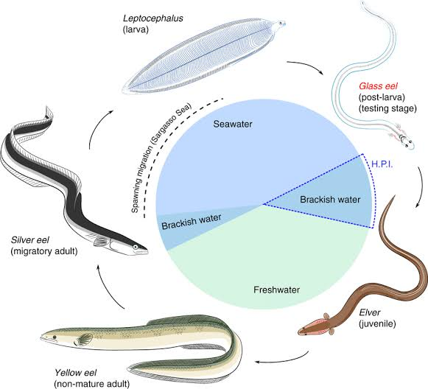
Figure 1: Life cycle of anguillid eels (source Cresci et al.,2019)
The early stage of the eel, the leptocephalus, is a distinctive larva with a highly laterally compressed and almost transparent body which primarily occurs in marine waters (Miller.,2009). From their spawning areas, leptocephali are transported along ocean currents at the continental shelf (Arai et al.,2016; Miller et al.,2018; Miller and Mc Cleave.,2018). Leptocephalus appear transparent in colour, mimicking gelatinous zooplankton, thus low incidence of predation at sea (Miller et al.,2018; Miller and Mc Cleave.,2018). Before arrival at estuaries leptocephali metamorphosize into transparent glass eels. Recruitment of glass eels into the estuaries from the sea is referred to as inshore migration (Arai et al.,2020). Prior to inshore migration glass eels undergo metamorphosis, developing of most organs such as intestine, gills and kidneys; as well as muscles and bones development (Otake., 2003). Upon entry into the estuary glass eels transitions its osmoregulatory system from one that eliminates excess salt and conserves water to the one where the whole reverse applies, so as to achieve homeostasis (Harrison et al.,2014).
At the stage of initial arrival in the estuary from the sea, glass eels are still almost completely transparent with no external pigmentation except a small rosette of pigment present around the top of the cranium (Strubberg., 1913; Arai., 2015). Ideally, glass eels carry out their migration into estuaries and then into fresh water (Dekker., 2002). Progressively, pigmentation darkens as the glass eels actively swim upstream transitioning into elvers, four to eight months after hatching to grow in freshwater habitats (Dekker.,2002; Harrison et al.,2014). After ascending upstream further into freshwater as elvers, the subsequent growing phase is termed as yellow eel (immature) which lives in freshwater habitats (Harrison et al.,2014). The timespan of this stage spans from a minimum of 7 years to a maximum of 50 years depending on factors such as species, sex, and geographic location (Hanzen. et al, 2019). The subsequent life stage from yellow eel is referred to as the silver eel. During the metamorphosis of yellow eels to silver eels, the ventral side of the body becomes more, whiter and reflective, their gonads develop, and their eyes increase in diameter by approximately 50% (REF). This metamorphosis coincides with the initiation of their downstream migration towards the marine habitat, where they ultimately reach the spawning grounds and subsequently die (Harrison et al.,2014; Arai.,2015). However, the silver eel migration period is one of the life stages that is still poorly understood (Harrison et al.,2014).

Oceanic Migration and Spawning of Anguillid Eels
Temperate anguillid eels are characterized by clearly defined, spawning and recruiting seasons (Tsukamoto., 2009; Robinet et al., 2003; Arai and Siti., 2016). The spawning migration of temperate eels generally occurs during autumn months between August and December in the Northern Hemisphere and between February and May in the Southern Hemisphere, except in a case of the prolonged downstream migration activity between April and December with high temporal variation in the European eel in northeastern Germany (Tsukamoto.,2009; Arai and Siti.,2016). According to molecular phylogeny, tropical eels are the most basal species known to radiate out from the tropics to colonize temperate regions (Arai and Siti.,2016).
Compared to temperate anguillids spawning period of tropical anguillids is not well understood (Harrison et al.,2014). According to Jespersen, (1942) all four tropical anguillid eel species share a similar spawning area located east of Madagascar. However, Pous et al.,(2010) stated that tropical anguillid eels have different spawning areas closely linked through migratory routes to their recruitment sites. Anguilla mossambica is thought to breed east of Madagascar but moves southwest on its way to the Mozambique coast and South African rivers (Réveillac et al.,2009). Jubb, (1961) projected that juvenile of A. mossambica possibly reach the mainland coast between latitude 21°S at the border between Mozambique and Tanzania and 31°S southern coast of KwaZulu-Natal in South Africa. It is also proposed that their leptocephali are transported southwards by the South Equatorial Current (SEC) with migration distances in the order of 1,000 to 2,000 km (Réveillac et al.,2009).
Anguilla bicolor has two potential spawning area southwest of Sumatra (Jespersen, 1942; Arai et al.,1999) and northeast of Madagascar (Robinet and Feunteun.,2002). Even though its presence may be seen in eastward flowing rivers of east Africa, the species has not been recorded in Kenyan rivers (Pike et al.,2019a). Glass eel, elvers and post-elvers of A bengalensis have been recorded to follow a northern migration route around Madagascar reaching the coast north of latitude 20°S. (Robinnet et al.,2007; Réveillac et al.,2009;). According to Robinnet et al. (2007), A. marmorata has the widest distribution in the world and has been reported together with A mossambica in the islands of Mauritius and Réunion (Robinnet et al.,2007; Hanzen et al.,2019). Jespersen’s (1942) hypothesized that the larvae migration pattern of these two eel species are transported around the southern tip of Madagascar.
Documentation on the adult stages of anguillid eel’s distribution and spawning areas in the Western Indian Ocean are limited but have been documented by Gagnaire et al.,(2007) and Pous et al.,(2010). Among these studies available on the recruitment patterns of anguillid eels, most of them are of the Western Pacific (Yamamoto et al.,2001; Leander et al.,2012) and Indo-Pacific (Arai et al.,1999; Shirotori et al.,2016) whereas focus studies on recruiting juvenile stages in the SWIO are limited. Prior to subsequent studies by Robinet et al., 2003 glass eel recruitment periodicity in the region was thought to be yearlong and continuous. However, studies show that recruitment varies considerably among areas, with successive peaks in estuarine migration, when conditions are favourable (Robinet et al.,2003). Glass eels of A. bicolor, A. benegalensis, and A mossambica arrive at the rivers of the eastern coast of Africa from January to February (Robinet et al.,2003). It is not clear whether similar recruitment patterns occur along Kenyan rivers and hence the current study.

Upstream migration
While the catadromous life cycle of anguillid eels show that they migrate between marine and freshwater habitats, some studies have documented that not all species of anguillid eels migrate upstream into freshwater habitats, but rather display facultative catadromy (Tsukamoto and Arai., 2001; Arai et al.,2013; Harrison et al.,2014). Recent studies on otolith chemistry show that anguillid eels have more adaptable life histories than previously studied (REF). Anguillid eels have been reported to exhibit facultative catadromy by either migrating between rivers and estuarine habitats or migrating between seawater and estuarine habitats of multiple freshwater rivers (Hanzen., 2020; Harrison et al.,2014). Studies on otolith microchemistry of temperate anguillid eels have also shown that, some yellow and silver stages, spend their entire life history in the ocean and never migrate into freshwaters (Arai et al.,2013).
According to the migratory life history of A mossambica and A marmorata, otolith ratio of Strontium:Calcium ratios of sampled by Lin et al., (2012) from South African rivers, showed that after inshore migration as glass eels, elvers of both species resided in estuarine habitats awaiting favourable river flow conditions during the wet season awaiting upstream migration. However, if the river flow is insufficient for upstream migration, elvers will most likely leave and travel along the coast in search of favourable habitats as an alternative option (Lin et al.,2012).
Facultative catadromy can be attributed to estuarine habitats being a significant and convenient environment for feeding or rearing for glass eels from their entry as juveniles up to silver eel life stage (Lin et al.,2012; Arai et al.,2013; Harrison et al.,2014). However, information on facultative catadromy has only been obtained for temperate anguillid eels and little is known about the utilization of environmental habitats by tropical anguillid eels in East African rivers (Hanzen et al.,2020; Arai et al.,2013).

Factors influencing the occurrence of juvenile anguillids
Anguillid eels possess a versatile ecological niche and can inhabit a diverse array of aquatic habitats throughout their complex lifecycle, including the open sea, coastal shelves, estuaries, and freshwater ecosystems (Righton et al., 2021). The underlying processes that regulate the migration of eels once they have reached the physiological stage, ready to migrate, remain a subject of ongoing investigation. Nonetheless, factors that are known to be associated with eel habitat selection include: water depth, temperature, salinity, substrate type, water flow, oxygen levels, vegetation cover, and biotic characteristics such as the availability of prey, the threat of predation, and the presence of other eels (Silberschneider et al., 2001; Righton et al., 2021). Majority of these variables have mostly been described for temperate juvenile anguillid eels whereas those of tropical juvenile anguillid eels are a rudimentary level (Arai et al.,2020). In contrast, what is mostly documented within the WIO is information on the recruitment and species composition of tropical juvenile eels within estuaries (Sugeha et al.,2001; Aoyama et al.,2015).
Anguillid eels respond to physicochemical properties such as temperature and salinity during migration and spawning (Schabetsberger et al.,2016). Temperature plays a crucial role in the survival, feeding, and growth of all fish species because it affects the rate of food passage, enzyme activity, and consumption of food through its impact on metabolic response rate (Briand., 2009). Temperature influences the commencement of active swimming behaviour with an average optimum temperature of 12ºC for temperate glass eels (Linton et al.,2007; Briand, 2009; Harrison et al.,2014). However, a shift in temperature to 8 ºC can alter the transition from passive to active at a salinity of 10ppt (Briand., 2009). Technically temperatures above 10ºC reduces the locomotive function of glass eels (Laffaille et al.,2007; Harrison et al.,2014) while temperatures lower than 6ºC reduce glass eel activity (Harrison et al.,2014). Study done by Linton et al., (2007 illustrated that that at temperatures between 17 and 25°C glass eels of A. anguilla exhibit both swimming and climbing behaviours.
Although it is considered as one of the chief environmental variables governing upstream eel migration, influence of temperature on juveniles of tropical anguillid eels is not well documented. Juveniles of A. marmorata are sensitive to low water temperature and have an optimal growth temperature of 27.6 °C (Luo et al., 2013). A study by (Arai et al., 2020) reported presence of A. bengalensis specimens in upstream locations with temperatures ranging from 23.6 to 28.1 °C. Due to moderate temperatures being continuous year-round and lack identifiable seasons in the tropics, water temperature may not be a factor in tropical glass eels' inshore migration (Arai et al.,2020).
Inshore migration of glass eels is influenced by light intensity (Arai et al.,2020) As documented by Laffaille (2007), light intensity plays a role in glass eel migration, showing an increase in migration activity in the dark during the first hour of darkness, during which they move closer to the surface as compared to their activity during the day (Bardonnet et al.,2003; Laffaille, 2007). However, this variable is still debatable, since Bardonnet et al. (2005) reported that light intensity has no inﬂuence on glass eel migration. While studying upstream migration of temperate species of glass eels in the Waikato River in New Zealand, Jellyman (1979) suggested that light has no influence on A. australis and A. dieffenbachii glass eels after observing that they migrated both during the day and night (Prouzet et al.,2009; Arai et al.,2020). Laffaille (2007) observed glass eels shifted towards the bottom of the bed when light intensity was high and were most actively moving and abundant at the bottom where light intensity was to a much lower degree. Similarly, experimented in an aquarium glass eels of A. japonica were observed to burrow in the sand during daytime (Dou and Tsukamoto 2003)
A correlation between light and lunar cycle highlights that glass eels remain in much deeper water columns during the full moon attributed to the high light intensity at that lunar period. A study by Sugeha et al. (2001) in the Poigar estuary recorded fewer glass eels during the full moon and higher glass eels collected during the new moon as compared to the waxing and waning moons. Arai et al., (2020) reported both lunar and semilunar periodicity of inshore migration by glass eels, with high number of glass eels observed to recruit during the new moon phase as compared to the full moon phase. Thereby, high moonlight intensity does play a role in influencing both inshore and upstream migration. However, it is debated that lunar effect has no influence in highly turbid estuaries (Harrison et al.,2014). Turbid conditions reduce light penetration thus making lunar periods have no significant influence on migrating juvenile anguillids. Additionally, high turbidity may decrease predation rates guaranteeing higher survival and successful upstream migration (Lunt and Smee.,2020).

CHAPTER THREE

MATERIALS AND METHODS

Study area
The study was conducted in the Sabaki Estuary. The estuary located 10km north of Malindi town and lies between longitude: 3.2ºS and latitude: 40.15º occupying approximately 250 ha (Abuodha, 1998; Houte-Howes, 2005). The estuary arises from the downstream lower course of the Athi river which flows 220 km through the semi-arid savannah plains. As the river, its name changes along the course, emptying into the West Indian Ocean near the Malindi–Watamu reef complex and is referred to as the Sabaki River (Katwijik et al.,1993; Marwik et al.,2014).
The Sabaki Estuary is made up of two main zones; an intertidal muddy area with mangroves and the main tidal channel, characterized by spring and neap tide, seasonal tidal effects (Kitheka et al.,2015; Kitheka et al.,2016). Considered seasonal, the estuary has interchanging low (see figure 2) and high waters at each tidal cycle (Kitheka et al.,2016) with mean shallow depths of 3m with seawater not obtruding permanently into the estuary but is rather flashed out at every tidal cycle (Kitheka et al.,2015; Kitheka et al.,2016).
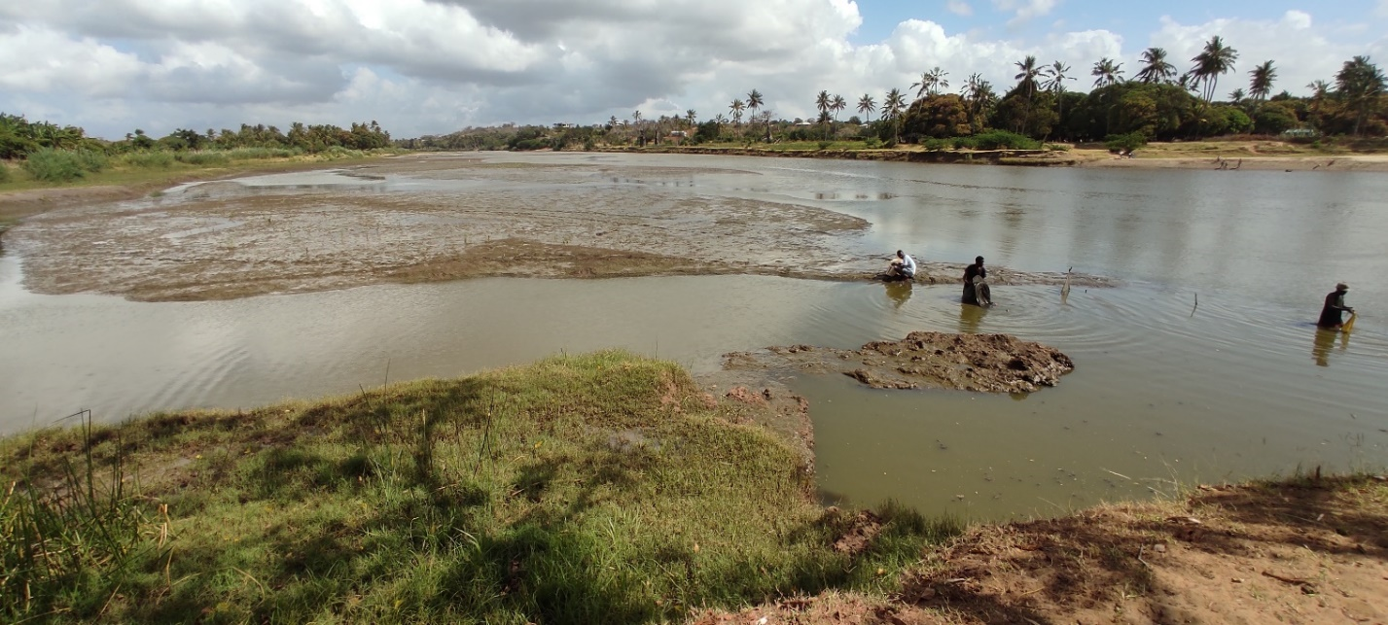
Figure 2: Picture of the Sabaki Estuary at low tide
Sabaki Estuary experiences a tropical monsoon climate with two distinct rainfall seasons; the kaskazi; Northeast Monsoon (NEM) and kusi; Southeast Monsoon (SEM) season (Houte-Howe, 2005; Kitheka et al.,2013). The NEM season occurs between October and March, characterized by calm and warm sea and fewer rains, whereas the SEM season occurs between March and September characterized by rough and cool sea, more rains, stronger winds and lower temperatures (Kitheka et al.,2013; Kitheka et al.,2015). NEM is associated with the short rains with the peak rainfall occurring in November whereas, SEM is associated with the long rains occurring between March and June with peak rainfall in April in the hinterland and May along the coast (Kitheka, 2013; Kitheka et al.,2015; Kitheka., 2016).
The estuary intertidal muddy area is characterized by mudflats of dark brown clay mud deposits colonized by a variety of mangrove trees (Kitheka et al.,2013; Kitheka et al.,2015). Inhabiting mostly the lower region of the estuary, the key species of mangroves present are Aviccenia marina, Rhizophora mucronata, Bruguiera gymnorrhiza, Xylocarpus granatun and Ceriops tagal (Kitheka et al.,2013).
In addition to flora, the estuary is considered a vital ecosystem for fish biodiversity with 20 marine and 39 freshwater riverine fish families dominated by Cyprinidae, Cichlidae, Morymyridae and Gobiidae as reported by Okeyo (1998). The Sabaki Estuary also serves as bird sanctuary for feeding grounds and roosting sites for large numbers of gulls and terns, non-breeding Lesser Flamingos Phoeniconaias minor and some rarer species such as Broad-billed Sandpiper Limicola falcinellus (Kitheka et al.,2013; Houte-Howes.,2005). Home to the commercial shrimp fishery, inshore shrimp species mainly found include Feneropenaeus indicus, Penaeus monodon, Penaeus semisulcatus, Penaeusjaponicus and Metapenaeus Monoceros (Fulanda et al.,2011; Munga et al.,2012; Munga et al.,2013).
Fishers within the estuary employ traditional small dugout canoes, locally referred to as such as mtumbwi, hori, ngalawa and dau (Fulanda et al.,2011) and traditional fishing gears; this is due to their low-cost nature making them easy accessibility to fishers (McClanahan & Mangi.,2004; Munga et al.,2014). Dominant fishing gears used in the estuary range from traditional traps such as malema basket traps, to modern gears and tidal weirs or hand lines and long lines, and drift and gillnets. Fulanda et al.,2011; Munga et al.,2016). However, artisanal fishers in the estuary are mostly inclined to fishing at the seaward side ﬁshing grounds (Munga et al.,2012).

Sampling Design and Data Collection
In the present study, the estuary was divided into four sampling regions; SBE1, SBE2, SBE3 and SB4. SBE4 (3°09'11"S 40°07'40"E) occurs 1.5km proximate to the mouth. SBE1 (3°08'58"S 40°07'13"E), SBE2 (3°08'57"S 40°07'19"E) and SBE3 (3°08'52"S 40°07'28"E) occurred between distances 0.5 km from each other. SBE1, SBE2 and SBE4 are characterized by vegetation edges at the banks with Prosopis juliflora trees being the most predominant with small scale agricultural farming and irrigation occurring around the estuary banks. SBE3 (3°08'52"S 40°07'28"E) is characterized by rocky and muddy biotope. Map showing sapling stations is presented in figure 3.
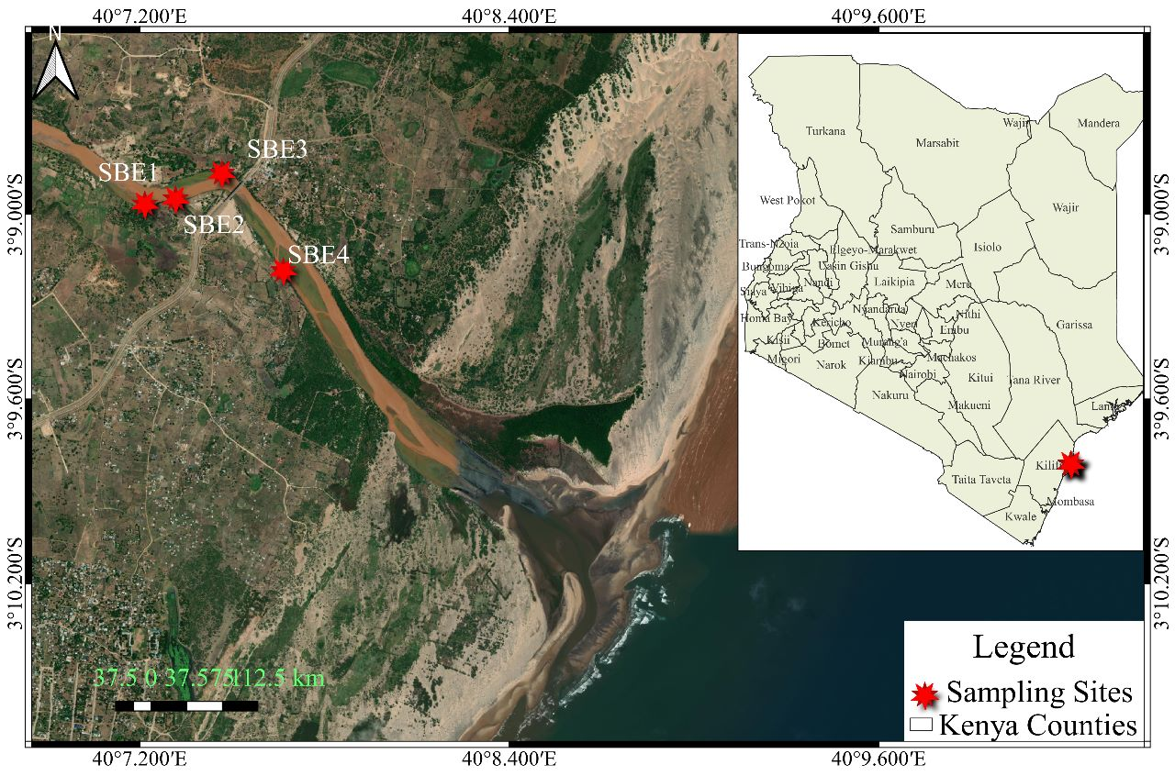Figure 3: Sampling stations marked in red along the Sabaki Estuary

Identifying the life stages, species and temporal influence of juvenile anguillid eels occurring in the Sabaki Estuary
Juvenile anguillid eels were caught using very fine mesh glass eel fyke nets, which are designed for commercial glass eel fisheries in Australia (T&L netmaking, Mooroolbark, Australia). Sampling was done monthly, over a period of 5 consecutive nights by setting 4 fyke nets at each of the four sampling locations. Fyke nets were deployed at noon, during low tide and installed using poles anchored firmly into the substrate, with the cod end secured to vegetation and the two wings facing seaward as seen in see figure 4 in two distinctive habitat characterized by vegetative edges and rocky/muddy areas. Global Positioning System (GPS) of each glass eel fyke net were recorded.
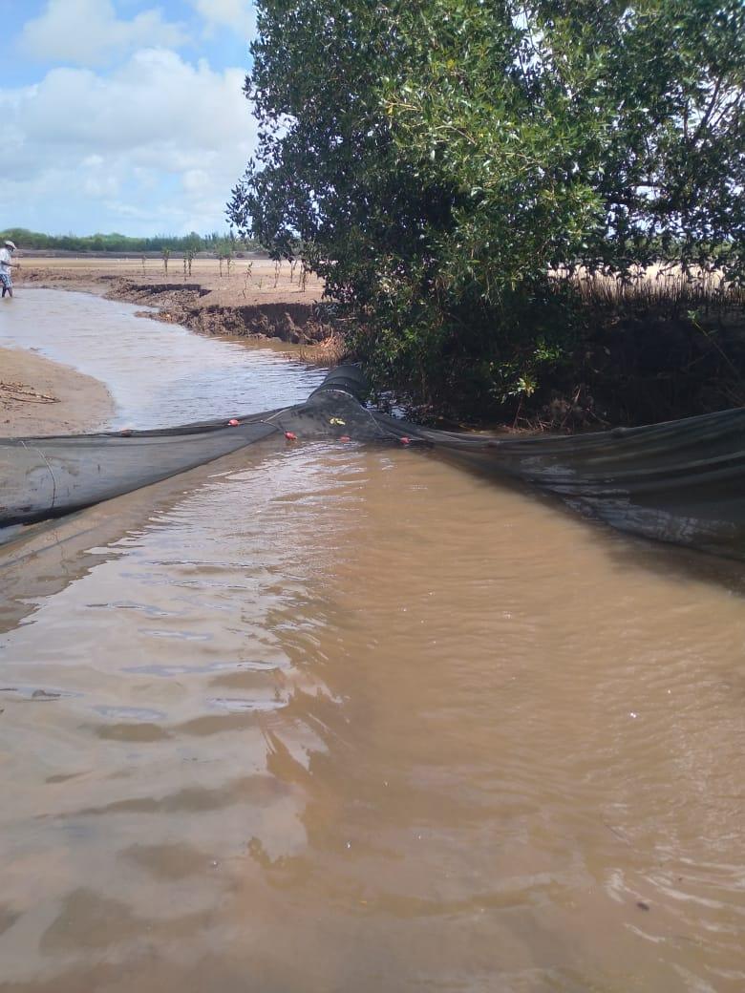
Figure 4: Glass eel fyke net anchored along the bank of the Sabaki Estuary facing seaward
The nets were checked at dawn and the catch was transferred to a bucket of estuary water. Contents from the bucket was then be sieved through 500mm mesh net and the catch sorted to species. Fish were measured for total and standard length (to the nearest 0.1 cm) on a fish length measuring board and weighed on an electronic top loading balance (to the nearest 0.1g). Juvenile anguillid eels captured were measured for total length only (to the nearest 0.1 cm), their life stage identified from their external body pigmentation. Juvenile anguillid eels with colourless body pigmentation were classified as glass eels while those with pigmentation were identified as elvers and data recorded. Juvenile anguillid samples were then stored in sampling bottles, in 99% absolute ethanol for further morphological identification at the Kenya Marine Research Institute (KEMFRI) laboratories. In the laboratory, specimens of juvenile anguillid eels were determined by observing their tail pigmentation, under a microscope (Stemi 305, Carl Zeiss Microscopy GmbH, Germany) at 2x magnification and individual photographs taken using ZEN imaging software (Carl Zeiss Microscopy GmbH). Identification was done according to (Revelliac et al.,2009) protocol. Additionally, eye morphometrics were measured both vertically and horizontally under a microscope using ZEN software at x2 for all glass eels and x1 for all elvers and recorded in micrometers (µm).

Establishing whether physiochemical parameters and lunar cycle influence the abundance of juvenile anguillid eels.
During retrieval of the catch, data on physicochemical parameters were obtained using a hand-held water quality meter. At each sampling region; SBE1, SBE2, SBE3 and SBE4, the water quality meter was lowered in water adjacent to the deployed sampling fyke net, as seen in figure 5 and the reading recorded.
Lunar phases were categorized into five groups, which were full moon, waning gibbous, last quarter moon, first quarter moon and waning crescent moon and new moon. Daily moon phase data as well, moonset and moon rising timings were obtained from Vitalii (2019) and data recorded.
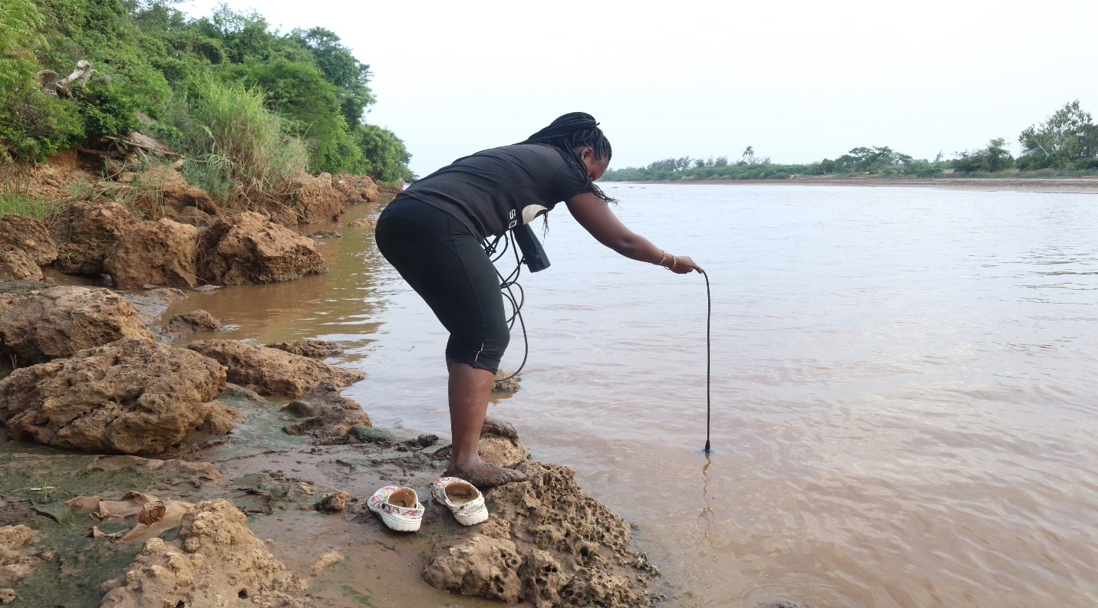
Figure 5: Measuring physiochemical parameter next to an anchored glass eel fyke net.

Data Analysis

Data Preparation
The collected and recorded data was passed through a data cleaning and tidying process before any analysis could be done. All the typing errors in the species names, families and common names were corrected and rectified. This made sure that the species name, common name and local names collated with all species. The physiochemical parameters were aligned with the respective study sites and species caught in those sites. The missing values were imputed, and outliers excluded from the dataset. The data preparation phase produced a meaningful rectangular data, free of outliers and missing values. The data was then ready for both descriptive and inferential statistics.

Descriptive Statistics
The descriptive statistics were illustrated in tables of frequencies and proportions. All species caught were illustrated in tables describing, the local names, common names and species name with corresponding abundance in form of individual counts as well as their average standard lengths, total lengths and average weight in grams. The tables thus described both the target species and the by-catch of the study with corresponding statistics. The recruitment of species was described across different seasons, habitat sites, months and phases of the moon. The prevailing physiochemical parameters in sites where the species were caught were also described in means and standard deviations.

Inferential Statistics
Few statistical tests were used in this study. First, the chi-square test was used to determine the existence of association between species caught and the phase of the moon, the site of recruitment, the month of recruitment and the biotope of recruitment. A one-way analysis of variance was employed in determining the significance of differences in the phenotypic morphometry of the different species caught. An ANOVA test of significance was also utilized in determining variability of physiochemical parameters associated with the recruitment of each species. The catch per unit effort in terms of catch per trap per day were calculated by dividing the total individual species caught with nets used in a 24-hour period. The catch per trap per day was illustrated for every species in a table. The catch per unit effort was done for the juvenile target species and the overall species caught during the study. All tests of significance utilized 0.05 alpha level or a 95% confidence interval.

CHAPTER FOUR

RESULTS

Summary of species caught
As illustrated in the table 1 below, 15 different species belonging to 10 families were caught during the study. Since only Anguillidae family was the target, 9 different families were caught as by-catch. The species Glossogobius giuris (tank goby) dominated the estuary in abundance by 947 counts followed by the Sabaki tilapia, Oreochromis spirulus spirulus with 118 individuals while the genus of interest, Anguillidae came third in abundance with A. bengalensis having 50 individuals. Therefore, tank goby and the Sabaki tilapia dominated the by-catch of the study. The Mozambique tilapia and snake eel followed closely at 47 and 45 counts respectively. Among the target species, A. bengalensis had the highest abundance of 50 individuals followed by A. mossambica with 23 individuals while A. marmorata trailed with only 3 individual species. Table 2 below also illustrates the catch per unit effort, in terms of catch per trap per day of species caught in the study.

Glossogobius giuris from the Gobiidae family dominated the catch with 947 individuals. Glossogobius giuris locaaly known as the Jumburu, had an average total length of 14 cm and a standard length of 10 cm while weighing 23 grams. The sabaki tilapia followed distantly in abundance with 118 individuals with an average weight of 26 grams with a standard length and total length of 12 cm and 15 cm respectively. The anguillidae family came third with 50 individuals from the Anguilla bengalensis species. The Anguilla bengalensis had an average total length of 5.5 cm weighing 5 grams. The Mozambique tilapia followed with 47 individuals, then the snake eels with 45 individuals. The snake eels were the longest having a total length of 108 cm weighing 71 grams. Table 1 illustrates the summary results of the caught species. The target species which belonged to the Anguilla family were Anguilla bengalensis which led with 50 individuals, followed Anguilla mosambica with 23 individuals and Anguilla marmorata with 2 individuals.
Table 1: Summary of species caught in the study area
Species | Family | English Name | Local name | Individual counts | Total Length | Standard Length | Weight (g)
Glossogobius giuris | Gobiidae | Tank goby | Jumburu | 947 | 14.55±3.11 | 10.01±0.99 | 23.26±3.18
Oreochromis spirulus spirulus | Cichlidae | Sabaki Tilapia | Parapara | 118 | 15.36±3.19 | 12.49±2.65 | 26.64±7.42
Anguilla bengalensis | Anguillidae | Indian mottled eel | Mkunga | 50 | 5.55±0.13 | NaN±NA | 5.2±NA
Oreochromis mossambicus | Cichlidae | Mozambique tilapia | Parapara | 47 | 16.33±3.69 | 11.79±2.68 | 15.88±3.01
Pisonodophis boro | Ophichthidae | Snake eel | Mkunga nyoka | 45 | 108.7±24.97 | NaN±NA | 71.35±6.14
Scylla serrata | Portunidae | Mud crab | Koe | 41 | 10.5±1.71 | 5.1±0.58 | 21.3±8.33
Bagrus docmak | Bagridae | Sudan catfish | Fume | 34 | 35.1±8.82 | 29.06±7.52 | 79±7.51
Stenogobius kenyae | Gobiidae | Africa river gobby | Black Jumburu | 25 | 69.97±8.4 | 57.04±6.62 | 17.32±6.3
Planiliza alata | Mugilidae | Diamond mullet | Mbinini | 24 | 4.26±0.17 | 4.97±1.34 | 2.67±1.12
Anguilla mossambica | Anguillidae | African longfine eel | Mkunga | 23 | 6.52±0.57 | NaN±NA | 5.25±0.15
Otolithes ruber | Sciaenidae | Tiger tooth croaker | Gufadi | 14 | 20.22±9.6 | 16.76±8.14 | 21.69±4.75
Penaeus indicus | Penaeidae | White Shrimp | Kamba | 5 | NaN±NA | NaN±NA | 528.38±66.82
Anguilla marmorata | Anguillidae | Giant mottled eel | Mkunga | 2 | 5±NA | NaN±NA | 5.1±NA
Barbus oxyrhynchus | Cyprinidae | Pangani barb | Karange | 1 | 124±NA | 97±NA | 19±NA
Penaeus indicus | Penaeidae | White Shrimp | prawns | 1 | NaN±NA | NaN±NA | 579±NA

Table 2: Overall catch per trap per day

Life stage and species occurring within the Sabaki Estuary

Life stage
A total of 76 juvenile anguillid eels were collected. The individual life stages observed to occur in the Sabaki Estuary were, glass eels, which appeared transparent in colour (see figure 6) and elvers which appeared pigmented (see figure 7). Glass eels were more abundant at 87% (n = 66) while elvers were less abundant at 13% (n = 10) as seen in table 3 below.

Table 3: Results showing life stages of occurring of juvenile anguillid eels in the Sabaki Estuary
Anguillid life stage | N = 76
Elver | 10 (13%)
Glass eel | 66 (87%)

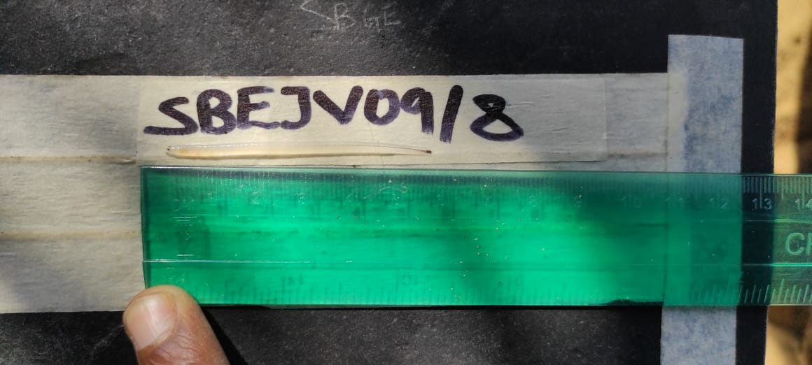
Figure 6: Picture displaying a glass eel, previously preserved in ethanol
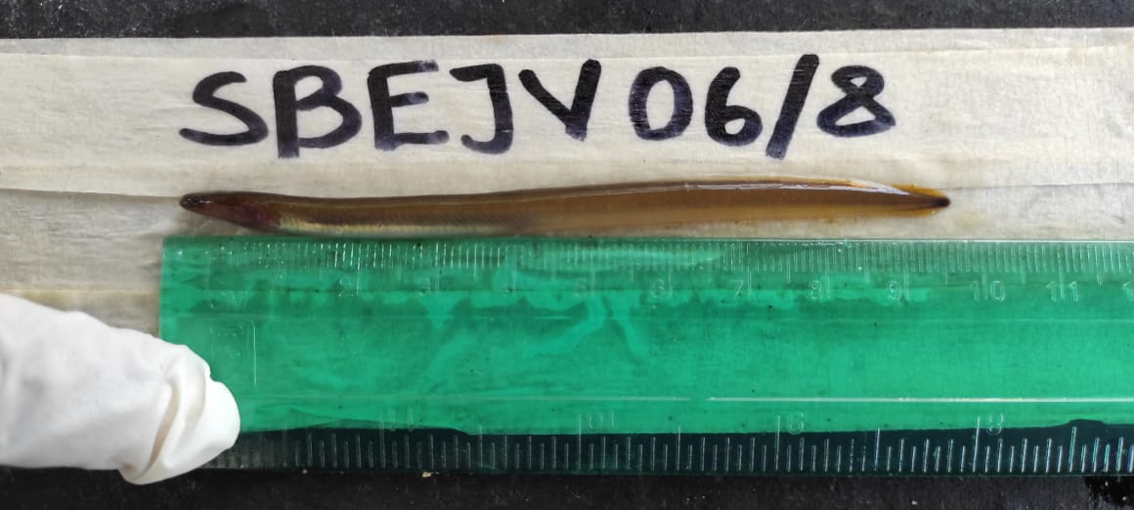
Figure 7: Picture displaying an elver occurring in Sabaki Estuary

Species
Identification of juvenile anguillid eels to species level was done through the observation of their tail pigmentation according to (Reveillac et al.,2009). Among the juvenile anguillid eels captured,A. bengalensis (see figure ) was the most abundant (n = 50). This was followed by A. mossambica (see figure 9), with 23 individuals while only 3 species of A. marmorata (see figure 10), were captured as seen in table 4.
Table 4: Species of anguillid eels caught
Family | Species | Local name | Species number
Anguillidae | A. bengalensis | Mkunga | 50
Anguillidae | A. mossambica | Mkunga | 23
Anguillidae | A. marmorata | Mkunga | 3

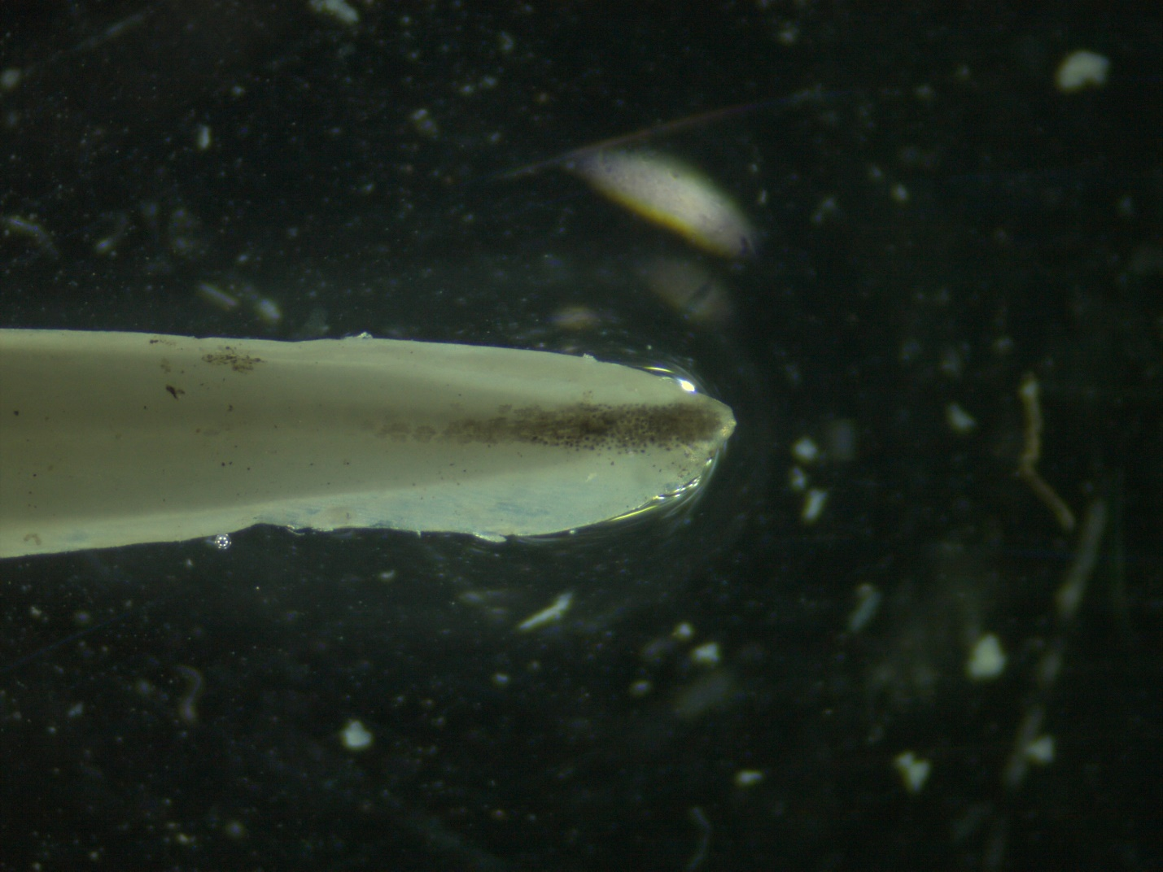
SBEJV22/8 (Anguilla bengalensis)
Figure 8: Tail pigmentation of A. bengalensis glass eel

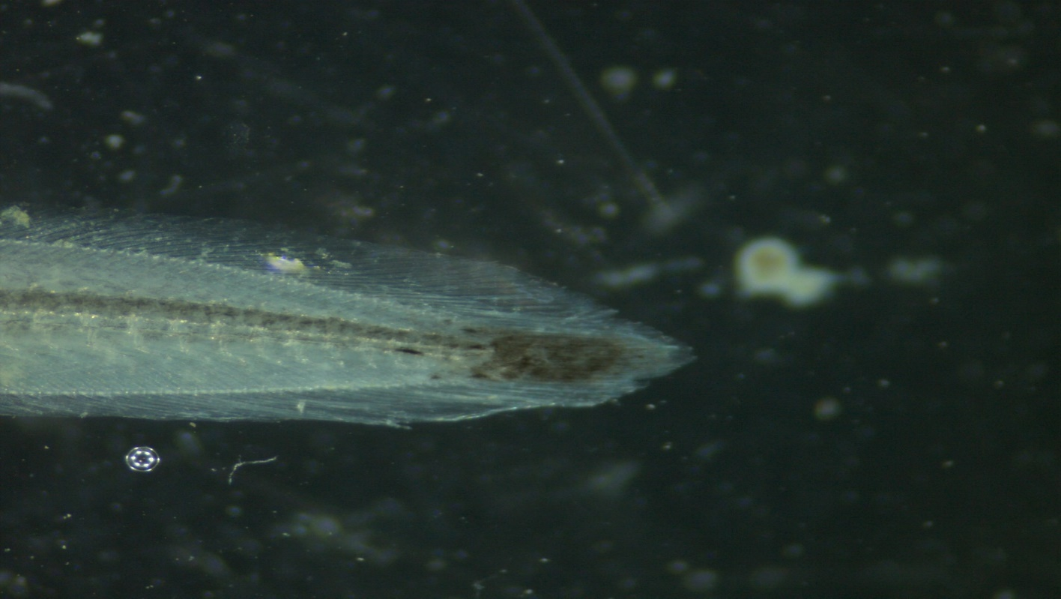
SBEJV05/8 (Anguilla mossambica)
Figure 9: Tail pigmentation of A. mossambica glass eel
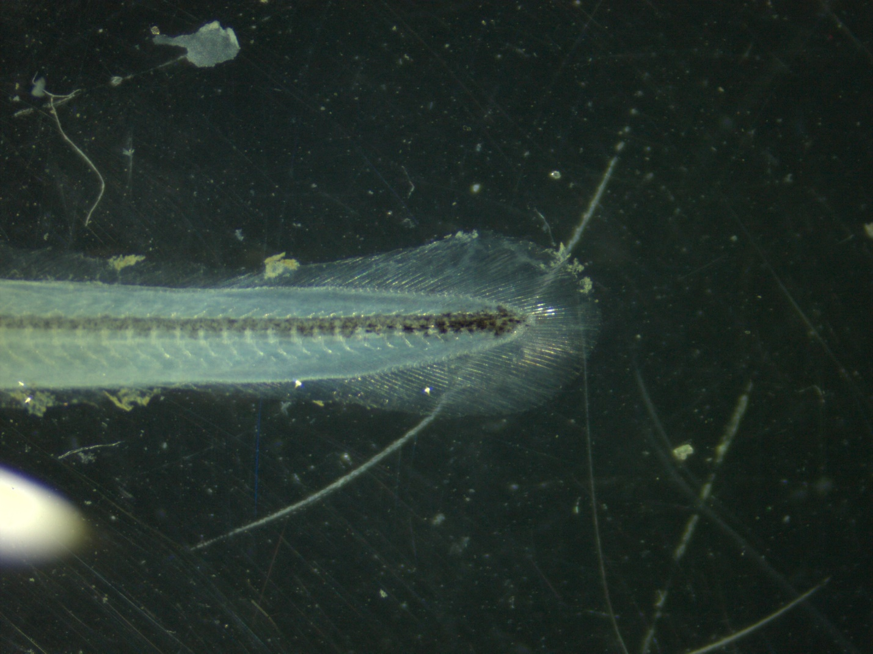
SBEJV04/8 (Anguilla marmorata)
Figure 10: Tail pigmentation of A. marmorata glass eel
As illustrated in table 5 below most of the juvenile anguillid eels caught were glass eels. Only A. mossambica and A. bengalensis species had elvers. A. bengalensis were the most abundant with 52 individuals with 50 being glass eels and 2 elvers. This was followed by A. mossambica with 22 individuals where the majority, 15 were glass eels while only 8 were elvers. Only two A. marmorata were caught during this study.
Table 5: Life Stages of juvenile anguillid eels caught
Family | Species | Stage | Specimen observed (n)
Anguillidae | A. bengalensis | Glass eel | 50
Anguillidae | A. mossambica | Glass eel | 14
Anguillidae | A. mossambica | Elver | 8
Anguillidae | A. bengalensis | Elver | 2
Anguillidae | A. marmorata | Glass eel | 2

Species morphometrics
Different morphometric measurements were recorded for each target species. The morphometric results are recorded in table 6 below; A. mossambica had the highest average total length of 6.29cm followed by A. bengalensis with an average total length of 5.43cm while A. marmorata registered the shortest average total length of 5.2 cm. Using a one-way analysis of variance (ANOVA) to determine whether the average total length among the species were statistically significant, the results of ANOVA showed that differences in total length among the three species were statistically significant (ANOVA, p = 0.007). Anguilla mossambica had the largest average DF to AF length with 249mm followed by A. marmorata with 125mm while A. bengalensis had the shortest average DF to AF length with 123mm. The mean differences in DF to AF lengths were statistically significant among the three different species as attested by the ANOVA results that showed statistical significance at critical level of 0.05 (ANOVA, p = 0.008).
All the morphometric measurements showed a similar trend with A. mossambica having the largest morphometric measurements followed by A. marmorata and trailed by A. bengalensis though they were not statistically significant. Anguilla mossambica had the largest DA length with 215mm while A. marmorata and A. bengalensis had the same DA length at 106mm. The mean differences in DA were statistically significant as indicated by an ANOVA analysis at an alpha value of 0.05 (p = 0.02). Therefore, in all morphometrics A. mossambica is the largest among the studied anguillids while A. bengalensis is the smallest.
Table 6: Morphometrics of juvenile anguillid species occurring in the Sabaki Estuary (TL = total length, DF to AF =dorsal fin t anal fin, DA = dorsal fin to anus, LH=left eye horizontal, LV=left eye vertical, RH=right eye horizontal, RV=Right eye vertical)
Morphometry | A. bengalensis | A. marmorata | A. mossambica | p-value
TL (cm) | 5.43 ± 0.53 | 5.20 ± 0.28 | 6.29 ± 1.81 | 0.007
DF to AF (mm) | 123 ± 42 | 125 ± 8 | 249 ± 282 | 0.008
DA (mm) | 106 ± 44 | 106 ± 10 | 215 ± 270 | 0.020
DG (cm) | 1.79 ± 0.62 | 1.90 ± 0.14 | 1.97 ± 0.63 | 0.5
LH (mm) | 63 ± 8 | 64 ± 9 | 82 ± 73 | 0.2
LV (mm) | 60 ± 10 | 62 ± 7 | 80 ± 75 | 0.15
RH (mm) | 60 ± 9 | 63 ± 5 | 80 ± 73 | 0.14
RV (mm) | 59 ± 9 | 67 ± 13 | 82 ± 75 | 0.10
¹Mean ± SD
²One-way ANOVA

Temporal variability

Species composition of juvenile anguillid eels captured across the sampling months
Table 7 below showed that majority of the species were caught during the month of August 67% (n=51), followed distantly by the month of November 14% (n=11) while the least individual species were caught in the months of July and September 2.6% (n=2) respectively. A chi-square test of association indicated lack of significant association between individual species caught and months of the study since the p value was greater than 0.05 (p = 0.2)
Table 7: Distribution of juvenile anguillid eel species across sampling months
 | Month
 | August | July | November | October | September | January | Total | p-value¹
Species |  |  |  |  |  |  |  | 0.2
A. bengalensis | 31 (41%) | 1 (1.3%) | 9 (12%) | 10 (13%) | 1 (1.3%) | 0 (0%) | 52 (68%)
A. marmorata | 2 (2.6%) | 0 (0%) | 0 (0%) | 0 (0%) | 0 (0%) | 0 (0%) | 2 (2.6%)
A. mossambica | 18 (24%) | 1 (1.3%) | 2 (2.6%) | 0 (0%) | 1 (1.3%) | 0 (0%) | 22 (29%)
Total | 51 (67%) | 2 (2.6%) | 11 (14%) | 10 (13%) | 2 (2.6%) | 0 (0%) | 76 (100%)
 | ¹Fisher's exact test

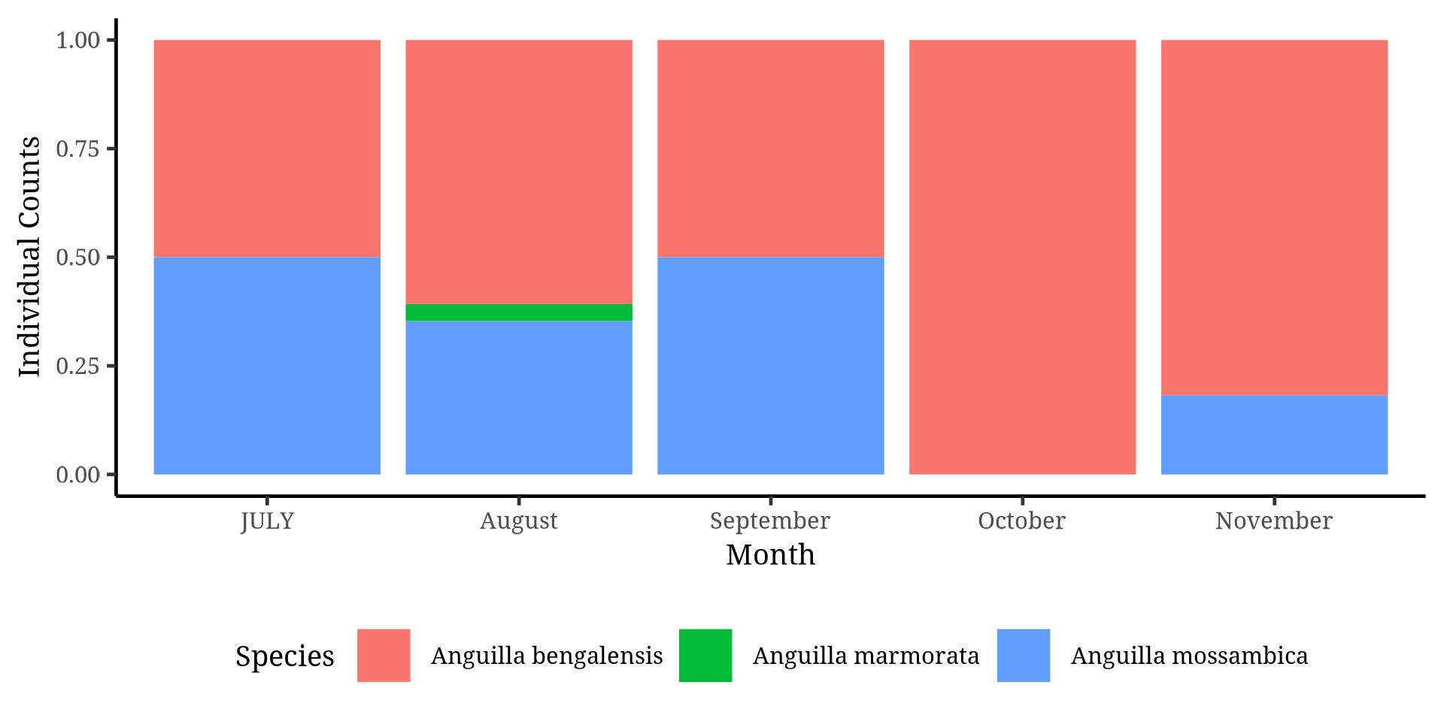

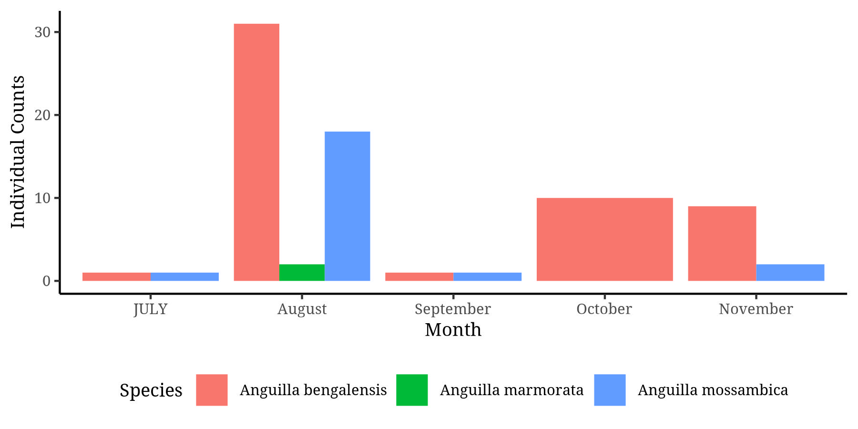

Species composition of juvenile anguillid eels captured across seasons
The results as illustrated in table 8 below, 70% (n=53) of all species were caught during the wet season while only 30% (n=23) were caught in the dry season. Anguilla marmorata were only caught during the wet season. The chi-square test of association indicated that there was no significant association between seasonality and the species caught (p = 0.06).
Table 8: Distribution of juvenile anguillid eels across different seasons
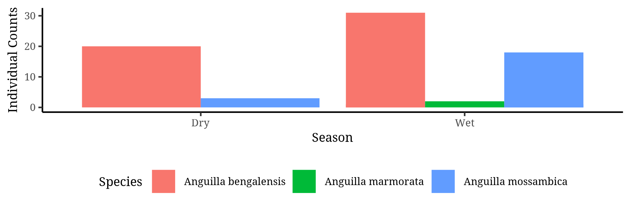

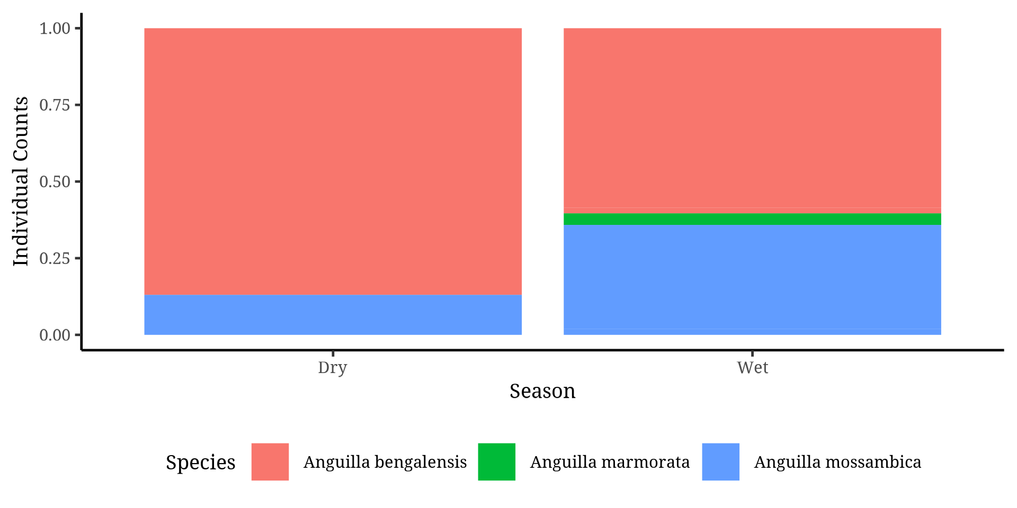
 | Season
 | Dry | Wet | Total | p-value¹
Species |  |  |  | 0.060
A. bengalensis | 20 (26%) | 32 (42%) | 52 (68%)
A. marmorata | 0 (0%) | 2 (2.6%) | 2 (2.6%)
A. mossambica | 3 (3.9%) | 19 (25%) | 22 (29%)
Total | 23 (30%) | 53 (70%) | 76 (100%)

Environmental influence on occurrence of juvenile anguillid eels

Association between juvenile anguillid eel species caught across habitat
A chi-square test of association was used to determine whether there existed an association between habitat and juvenile anguillid species caught. Table 9 below shows that majority of juvenile anguillid eels were majorly caught in vegetation edges 87% (n=66) while on 13% (n=10) of anguillid species were caught in rocky and muddy areas. In addition, the two A. marmorata species were only caught among vegetation edges. Chi-square test of association indicated that the juvenile anguillid eels caught were independent of the biotope (p=0.4).

Table 9: Species distribution sampled two across habitats
 | Habitat
 | Rocky/Muddy | Vegetation edges | Total | p-value¹
Species |  |  |  | 0.4
A. bengalensis | 5 (6.6%) | 47 (62%) | 52 (68%)
A. marmorata | 0 (0%) | 2 (2.6%) | 2 (2.6%)
A. mossambica | 5 (6.6%) | 17 (22%) | 22 (29%)
Total | 10 (13%) | 66 (87%) | 76 (100%)
¹Fisher's exact test

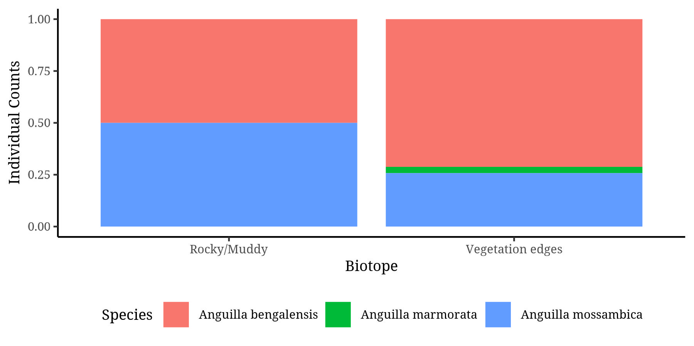

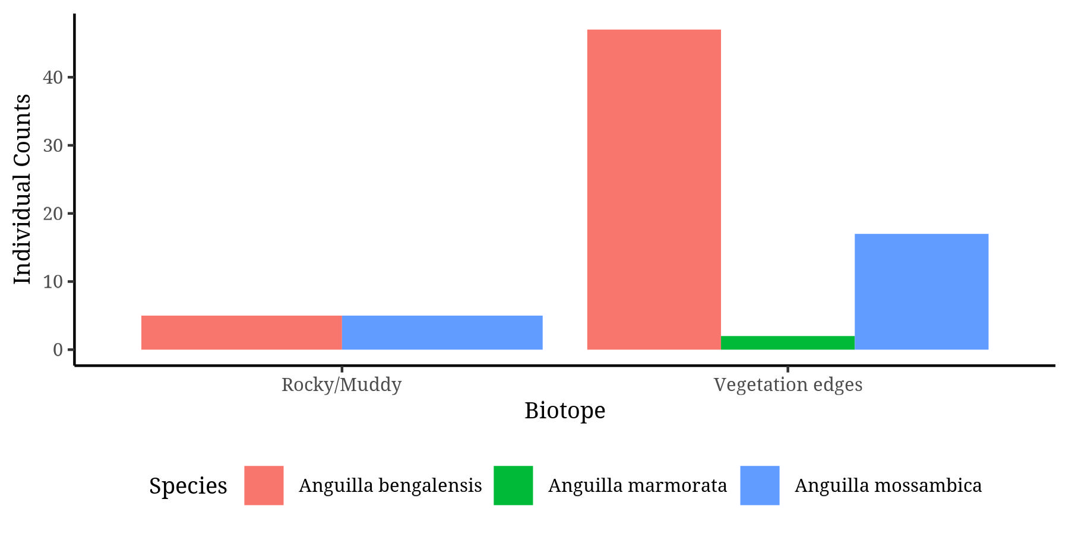

Association between juvenile anguillid eels and lunar cycle
Results illustrated in the table 10 below, indicated that there was no significant association between the species caught and the phases of the moon by use of a chi-square test of association (p = 0.2). However, the majority of the species were caught in wanning gibbous phase of the moon (37%), followed by first quarter moon phase (18%) while the least individual species were caught during the full moon phase.
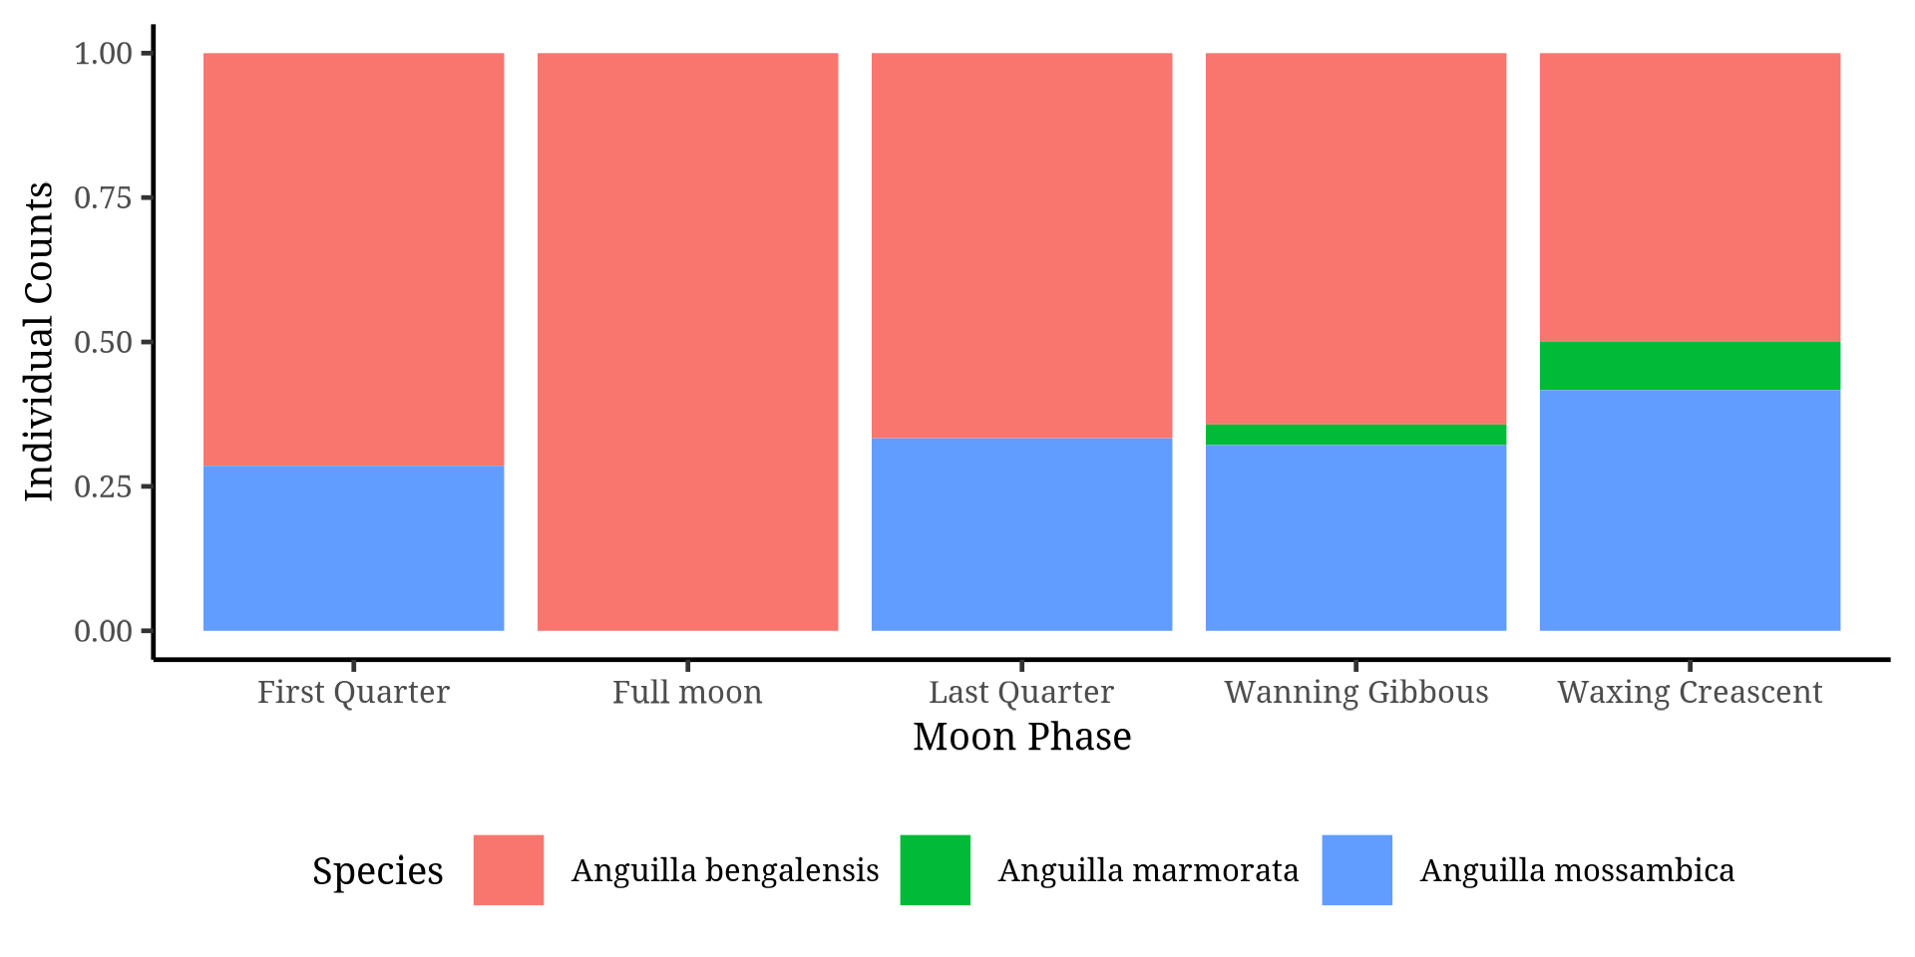
Table 10: Distribution of species across phases of the lunar cycles
 | Moon phase
 | First Quarter | Full moon | Last Quarter | Wanning Gibbous | Waxing Crescent | Total | p-value¹
Species |  |  |  |  |  |  | 0.2
A. bengalensis | 10 (13%) | 10 (13%) | 8 (11%) | 18 (24%) | 6 (7.9%) | 52 (68%)
A. marmorata | 0 (0%) | 0 (0%) | 0 (0%) | 1 (1.3%) | 1 (1.3%) | 2 (2.6%)
A. mossambica | 4 (5.3%) | 0 (0%) | 4 (5.3%) | 9 (12%) | 5 (6.6%) | 22 (29%)
Total | 14 (18%) | 10 (13%) | 12 (16%) | 28 (37%) | 12 (16%) | 76 (100%)

Site characteristics of juvenile anguillid eels

A. mossambica
As illustrated in table 11 there were 22 A. mossambica species caught during the study. The majority of the individual caught were at the glass eels’ stage 64% (n=14) while 36% (n=8) were elvers. 50% of the caught elvers were found in vegetation edges while 27% of the caught elvers were in vegetation edges making this biotope to be a habitat of 77% of the individuals while rocky and muddy biotopes were only habitats to 23% of A. mossambica. A chi-square test of association to determine the significance of association between life stage and biotope indicated absence of significant association (p > 0.9). The warning gibbous phase of the moon indicated the highest recruitment of A. Mossambica 41% (n=9) followed by waxing crescent phase of the moon 23% (n=5) while recruitment in the first and last quarters phases of the moon was the same at 4 species recruitment (18%). There was no association between phases of the moon and the life stage of A. mossambica (p=0.2). Seasonality did not affect the recruitment of the different life stages of A. mossambica (p = 0.3). Sampling period in terms of also months did not influence the recruitment of the different stages of A. mossambica (p = 0.8).
Table 11: Juvenile anguillid eels of A. mossambica across sampling site characteristics
 | Local name)
 | Elver | Glass eel | Total | p-value¹
Biotope |  |  |  | >0.9
Rocky/Muddy | 2 (9.1%) | 3 (14%) | 5 (23%)
Vegetation edges | 6 (27%) | 11 (50%) | 17 (77%)
Total | 8 (36%) | 14 (64%) | 22 (100%)
Moon Phase |  |  |  | 0.2
First Quarter | 0 (0%) | 4 (18%) | 4 (18%)
Last Quarter | 3 (14%) | 1 (4.5%) | 4 (18%)
Wanning Gibbous | 4 (18%) | 5 (23%) | 9 (41%)
Waxing crescent | 1 (4.5%) | 4 (18%) | 5 (23%)
Total | 8 (36%) | 14 (64%) | 22 (100%)
Season |  |  |  | 0.3
Dry | 0 (0%) | 3 (14%) | 3 (14%)
Wet | 8 (36%) | 11 (50%) | 19 (86%)
Total | 8 (36%) | 14 (64%) | 22 (100%)
Month |  |  |  | 0.8
August | 8 (36%) | 10 (45%) | 18 (82%)
July | 0 (0%) | 1 (4.5%) | 1 (4.5%)
November | 0 (0%) | 2 (9.1%) | 2 (9.1%)
September | 0 (0%) | 1 (4.5%) | 1 (4.5%)
January | 0 (0%) | 0 (0%) | 0 (0%)
Total | 8 (36%) | 14 (64%) | 22 (100%)
¹Fisher's exact test

A. bengalensis
Table 12 shows that biotope, phase of the moon, seasons and months of sampling did not have significant association with the life stage recruitment of A. bengalensis

Table 12: Juvenile anguillid eels of A. bengalensis across sampling site characteristic
 | Local name)
 | Elver | Glass eel | Total | p-value¹
Biotope |  |  |  | >0.9
Rocky/Muddy | 2 (9.1%) | 3 (14%) | 5 (23%)
Vegetation edges | 6 (27%) | 11 (50%) | 17 (77%)
Total | 8 (36%) | 14 (64%) | 22 (100%)
Moon Phase |  |  |  | 0.2
First Quarter | 0 (0%) | 4 (18%) | 4 (18%)
Last Quarter | 3 (14%) | 1 (4.5%) | 4 (18%)
Wanning Gibbous | 4 (18%) | 5 (23%) | 9 (41%)
Waxing crescent | 1 (4.5%) | 4 (18%) | 5 (23%)
Total | 8 (36%) | 14 (64%) | 22 (100%)
Season |  |  |  | 0.3
Dry | 0 (0%) | 3 (14%) | 3 (14%)
Wet | 8 (36%) | 11 (50%) | 19 (86%)
Total | 8 (36%) | 14 (64%) | 22 (100%)
Month |  |  |  | 0.8
August | 8 (36%) | 10 (45%) | 18 (82%)
July | 0 (0%) | 1 (4.5%) | 1 (4.5%)
November | 0 (0%) | 2 (9.1%) | 2 (9.1%)
September | 0 (0%) | 1 (4.5%) | 1 (4.5%)
January | 0 (0%) | 0 (0%) | 0 (0%)
Total | 8 (36%) | 14 (64%) | 22 (100%)
¹Fisher's exact test

Influence of physio-chemical parameters on juvenile anguillid eels caught
Analysis of physiochemical parameters in different biotope using students T-test showed that, statistically, physiochemical parameters did not significantly vary across two habitats sampled as shown in table 13.
Sampling sites had varying physiochemical characteristics. However, variations across the species were not statistically significant as illustrated in table 14 below. Statistical significance of physio-chemical parameters was derived using a one-way analysis of variance (ANOVA) which reported p values greater than 0.05 for every physiochemical parameter. Anguilla marmorata species were caught in sites with a higher basic pH (11.2) compared to the other two species, they were also found in areas with higher dissolved oxygen content (103), higher temperature (30.75) and higher salinity (1.34). Thus, A. marmorata species were caught in regions seemingly varying from the other species, although that difference was not significant.
Table 13: Physiochemical parameters across habitats
Physiochemical parameters | Rocky/Muddy, N = 10¹ | Vegetation edges, N = 66¹ | p-value²
pH | 9.57 ± 2.82 | 9.29 ± 2.43 | 0.7
Dissolved oxygen mg/l | 83 ± 55 | 82 ± 55 | >0.9
Conductivity (EC) (µS/cm) | 490 ± 191 | 534 ± 227 | 0.6
Temp (°c) | 27.71 ± 0.86 | 27.72 ± 2.74 | >0.9
Salinity (ppt) | 0.69 ± 0.81 | 0.72 ± 0.85 | >0.9
TDS (mg/l) | 900 ± 1,002 | 904 ± 973 | >0.9
Turbidity | 758.27 ± 6.24 | 757.22 ± 3.58 | 0.4

Table 14: Physiochemical parameters across species
Physiochemical Parameters | A. bengalensis | A. marmorata | A. mossambica | p-value
pH | 9.05 ± 2.58 | 11.12 ± 3.39 | 9.82 ± 2.08 | 0.3
Dissolved oxygen mg/l | 77 ± 52 | 103 ± 137 | 92 ± 54 | 0.5
Conductivity (EC) (µS/cm) | 551 ± 199 | 508 ± 88 | 477 ± 275 | 0.4
Temperature (°c) | 27.56 ± 2.71 | 30.75 ± 2.47 | 28.33 ± 2.03 | 0.14
Salinity (ppt) | 0.63 ± 0.81 | 1.34 ± 1.47 | 0.84 ± 0.87 | 0.4
TDS (mg/l) | 821 ± 939 | 1,644 ± 1,747 | 1,033 ± 994 | 0.4
Turbidity | 758 ± 6 | 756 ± 1 | 757 ± 5 | 0.6

Catch per unit effort for juvenile anguillid eels caught, per trap per day
As illustrated in the table 15 below, catch per unit effort calculated showed that the catch per trap per day for A. bengalensis was 20 individual species while it was 8 species for A. mossambica and 1 species per trap per day for A. marmorata. The results therefore showed that A. bengalensis require the least effort to be caught while A. marmorata require the largest effort to catch just a few of the individuals.
Table 15: Juveniles catch per trap per day

CHAPTER FIVE

DISCUSSION
The present study is the first to investigate the presence of juvenile anguillid eels within the Sabaki Estuary. We identified the juvenile anguillid life stages present within the estuary were the glass eel and elver life stages.
While there are many different species of eels however, those belonging to the genus Anguilla are the sole representatives of the Anguillidae family, which is one of the numerous families comprising the order Anguilliformes (Arai et al.,2002; Arai.,2015; Miller and Mc Cleave.,2018). In the present study, glass eels (n=66) were more abundant, while a very limited number of elvers (n=10) were captured.
Right after experiencing metamorphosis from the oceanic eel larvae-leptocephali, glass eels’ somatic cells decrease gradually, and commence their inshore migration as glass eels with a distinctive transparent and elongated body shape (Arai et al.,2002; Sugeha and Marlina.,2015). During their inshore migration, pigmentation initially appears on the caudal fin tip and nerve cord followed by the anterior side of the head and snout extending to the eyes (Fukuda et al.,2013; Sugeha and Marlina.,2015). Pigmentation then spreads forward covering half of the tail and then the preanal regions, after which the tip of the caudal fin along the dorsum to anterior of the dorsal fin become pigmented as well Fukuda et al.,2013. After several days within the estuary, glass eels usually have undergone haemostasis so as to adapt to estuarine habitat, pigment then uniformly covers the entire body and subsequently become elvers (Otake, 2003; Arai.,2005; Fukuda et al.,2013; Harrison et al.,2014 Sugeha and Marlina.,2015).
The species composition of juvenile anguillid eels present in the Sabaki Estuary was dominated by A. bengalensis. This was seen in the high catchability as highlighted by the catch per unit effort (CPUE) of A. bengalensis is 20 individual species per net per day. This coincided with Van Someren and Whitehead (1959) report which documented the abundance of adult A. bengalensis being the most dominant species in the Sabaki and Tana rivers. CPUE (8.8) data of A. marmorata, highlighted that the species requires a relatively high level of effort to capture a relatively low number of specimens. This suggested that, while A. marmorata is considered the most widely distributed, occurring in the southern Cape of South Africa all the way to the east African coast (Hanzen et al.,2020), it was however the least dominant species within the Sabaki Estuary. The difference in species abundance can be attributed to geographic ranges, temperature preferences, and behavioural patterns of adult anguillid eels. For instance, spawning grounds of adult anguillid eels and transportation of their larvae by different currents to their destination better explains the abundance of specific juvenile anguillid species (Fukuda et al.,2013).
Identification of juvenile anguillid eels to species level was based on the caudal pigmentation according to Revelliac et al.,2009 protocol to the species level. Descriptively, one morphological characteristic of tropical juvenile anguillid eels is their caudal fin, which appears rounded is pigmented (Revelliac et al.,2009). Tail pigmentation of A. mossambica juveniles appeared as a dark blotch just at the tip of the caudal keel, however, not extending towards the end of the caudal fin. Anguilla marmorata pigmentation begins from the tip of the caudal keel and extend inwards towards the body merging together with the medio-lateral line while A. bengalensis pigmentation begins from the tip of the caudal fin extending inwards towards the body merging together with the medio-lateral line.
The Sabaki estuary is spatially and temporally dynamic. The estuary displays varying physical and biological characteristics, from the open seawater near the mouth to upstream regions. Spatial variation in abundance of juvenile anguillid eels was evident. Studies have shown that glass eels have a preference for specific types of habitats, particularly those with vegetation. This could be due to the fact that habitats with vegetative cover provide crucial feeding areas that are essential for the juveniles anguillids growth and transition to the next stage of their life cycle.
In a controlled experiment, Glova, (1999) found that glass eels, when presented with different habitats, preferred substrate with watercress and to a lesser degree, woody debris. Glass eels and elvers also prefer complex natural habitats as a means of avoiding predation (REF). Study done by Silberschneider et al., (2001) utilized artificial habitat glass eel collectors, designed to mimic the complexity of Zostera seagrass, with a high number of interstitial spaces and featuring tactile fibres, which became even more pronounced with the growth of algae. The glass eel collectors were placed either vertically or horizontally on the substrate, mimicking complex natural habitats and when the collectors were disturbed, glass eels would burrow deeper into the protective tufts, replicating the protective behaviour that they display in their natural habitats.
Occurrence of juvenile anguillids also varied on a temporal scale. Juvenile anguillid eels was more abundant during the wet season compared to the dry season. For instance, a total of 51 individuals were caught in the month of August, compared to none in January. Similarly, a study done by Robinet et al., (2003) also reported higher recruitment of tropical anguillid eels in the Réunion Island during the wet season. According to Robinett et al., (2003), the wet seasons offer advantageous conditions for the recruitment process, due to the presence of freshwater runoff. Arguably, a study on fish community structure and distribution in the Sabaki river, Kimwaka, (2004) highlighted that during the wet season, the sea became rough leading to an increase in river discharge, bringing with it a significant amount of silt-laden runoff from the surrounding upland areas. This resulted to fish becoming dispersed over a much larger area, making it difficult to catch them. Thereby, it can be inferred that the juvenile anguillid eels possess a remarkable level of adaptability, being able to persevere through the challenging conditions present in estuaries during the wet seasons as they embark on their inshore and upstream migration.
While water quality did not significantly differ across the different habitats sampled, A marmorata species was observed to be prevalent in locations characterized by a relatively elevated pH level in comparison to the other two species. Furthermore, the presence of this species was also noted in areas that exhibited a higher concentration of dissolved oxygen, a higher temperature, and a higher salinity than other sampled sites. The adaptive capability of A marmorata to endure a broad range of water quality parameters can be attributed to its extensive geographical distribution throughout the tropical and sub-tropical regions of the western Pacific and Indian Oceans, thereby rendering it capable of tolerating a broad spectrum of environmental variations.

CHAPTER SIX

CONCLUSION AND RECOMMENDATIONS
This study is the first to document the presence of juvenile anguillid eels in one of the Kenyan estuaries. The results of this study have significance in terms of enhancing our understanding of the biology, taxonomy and ecology of juvenile anguillid eels. It would be beneficial to conduct a subsequent study that examines the correlation between external morphological identification and genetic identification in order to genetically discern the specific species recruiting within the Sabaki Estuary. Such a study needs to encompass accurate genetic identification and characterization of individual juvenile anguillids, which is essential for understanding their distribution, migration patterns and population dynamics monitored over a relatively longer period of time. Thereby there is a need for further taxonomic studies in this field. Furthermore, it is my aspiration that this study will serve as a foundation for the implementation of subsequent conservation and management strategies pertaining to these species in the future

REFERENCE
Abuodha JOZ. 1998. Geology, geomorphology, oceanography and meteorology of Malindi Bay. In Hoorweg ed Dunes, groundwater, mangroves and birdlife in Coastal Kenya. (pp. 17-39). Coastal Ecology Series No.4. Nairobi: ACT.
Arai T and Abdul Kadir SR. (2017). Opportunistic spawning of tropical anguillid eels Anguilla bicolor bicolor and A. bengalensis bengalensis. Scientific reports 30;7(1):1-7.
Arai T and Wong L. 2016. Validation of the occurrence of the tropical eels, Anguilla bengalensis bengalensis and A. bicolor bicolor at Langkawi Island in Peninsular Malaysia, Malaysia. Tropical Ecology 57: 23-3.
Arai T, Abdul Kadir SR and Chino N. (2016). Year-round spawning by a tropical catadromous eel Anguilla bicolor bicolor. Marine Biology. 2016 Feb;163(2):1-7.
Arai T, Aoyama J, Limbong D and Tsukamoto K. 1999. Species composition and inshore migration of the tropical eels Anguilla spp. recruiting into the estuary of the Poigar River, Sulawesi Island. Marine Ecology Progress Series, 188, pp.299-303.
Arai T, Chai IJ, Iizuka Y and Chang CW. 2020. Habitat segregation and migration in tropical anguillid eels, Anguilla bengalensis bengalensis and A. bicolor bicolor. Scientific Reports 10(1):1-3. Righton D, Piper A, Aarestrup K, Amilhat E, Belpaire C, Casselman J, Castonguay M, Díaz E, Dörner H, Faliex E and Feunteun E. 2021. Important questions to progress science and sustainable management of anguillid eels. Fish and Fisheries 4:762-88.
Arai T, Marui M, Otake T and Tsukamoto K. 2002. Inshore migration of a tropical eel, Anguilla marmorata, from Taiwanese and Japanese coasts. Fisheries Science, 68; 152–157.
Arai T, Sugeha HY, Limbong D, Tsukamoto K. (2020). Rhythmic activity of inshore migration of tropical freshwater glass eels of the genus Anguilla. Environmental Biology of Fishes 103(11):1295-308.
Arai T. 2015. Biology and ecology of anguillid eels. CRC Press Taylor & Francis Group 13: 978-1-4822-5516-4.
Bardonnet A, Bolliet V, Belon V. 2005. Recruitment abundance estimation: role of glass eel (Anguilla anguilla L.) response to light. Journal of Experimental Marine Biology and Ecology 13;321(2):181-90.
Bardonnet A, Dasse S, Parade M, Heland M. 2003. Study of glass-eel’s movements in a flume in relation to nycthemeral changes. Bulletin Français de la Pêche et de la Pisciculture (France). 2003.
Briand C. 2009. Population and migration dynamics of glass eels in the Vilaine estuary. Doctoral dissertation, Rennes, Agrocampus Ouest.
Cresci A, Durif CM, Paris CB, Shema SD, Skiftesvik AB and Browman HI. 2019. Glass eels (Anguilla anguilla) imprint the magnetic direction of tidal currents from their juvenile estuaries. Communications biology 2(1):1-8
Cresci A. 2020. A comprehensive hypothesis on the migration of European glass eels (Anguilla anguilla). Biological Reviews.
Criales MM, Robblee MB, Browder JA, Cardenas H and Jackson TL. 2011. Field observations on selective tidal-stream transport for postlarval and juvenile pink shrimp in Florida Bay. Journal of Crustacean Biology 31(1):26-33.
De Lima ÁC and Araujo‐Lima CA. 2004. The distributions of larval and juvenile fishes in Amazonian rivers of different nutrient status. Freshwater Biology 49(6):787-800.
Deelder CL. 1958. On the behavior of elvers (Anguilla vulgaris) migrating from the sea into fresh water. ICES Journal of Marine Science. 1958 Nov 1;24(1):135-46.
Dekker W, Casselman JM, Cairns DK, Tsukamoto K, Jellyman D and Lickers H. 2003. Worldwide decline of eel resources necessitates immediate action. Quebec Declaration of Concern. Fisheries 28, 28–30.
Dekker W. 2002. Monitoring of glass eel recruitment. Netherlands Institute of Fisheries Research, report C007/02-WD, 256 pp.
Derouiche E, Hizem Habbechi B, Kraiem MM, Elie P. 2016. Estimates of escapement, exploitation rate, and number of downstream migrating European eels Anguilla anguilla in Ichkeul Lake (Northern Tunisia). ICES Journal of Marine Science 1;73(1):142-9.
Duvail, S., Médard, C., Hamerlynck, O., and Nyingi, D. W. (2012). Land and water grabbing in an East African coastal wetland: The case of the Tana delta. Water Alternatives, 5(2), 322.
Dzoga, M., Simatele, D., & Munga, C. (2018). Assessment of ecological vulnerability to climate variability on coastal fishing communities: A study of Ungwana Bay and Lower Tana Estuary, Kenya. Ocean & Coastal Management, 163: 437–444.
Ege V. 1939. A revision of the genus Anguilla Shaw: a systematic, phylogenetic and geographical study. Dana Rep 16: 1–256.
Elliott, M., Whitfield, A.K., Potter, I.C., Blaber, S.J., Cyrus, D.P., Nordlie, F.G. and Harrison, T.D. (2007). The guild approach to categorizing estuarine fish assemblages: a global review. Fish and fisheries,8(3), 241-268.
Engelbrecht J, Bills R, Marshall B and Cambray J. 2010. Anguilla bengalensis ssp. labiata. The IUCN Red List of Threatened Species 2010: e.T183182A8070107.
Fleitmann D, Dunbar RB, McCulloch M, Mudelsee M, Vuille M, McClanahan TR, Cole JE and Eggins S. 2007. East African soil erosion recorded in a 300 year old coral colony from Kenya. Geophysical Research Letters 34(4).
Francis, M.P. (2006). Morphometric minefields—towards a measurement standard for chondrichthyan fishes. Environmental Biology of Fishes, 77: 407-421.
Froese R. and Pauly D. Editors. 2019. Fish Base. World Wide Web electronic publication.www.fishbase.org, (06/2019)
Froese, R. and D. Pauly. Editors. (2019). Fish Base. World Wide Web electronic publication.www.fishbase.org, (06/2019)
Fulanda B, Ohtomi J, Mueni E, Kimani E. 2011. Fishery trends, resource-use and management system in the Ungwana Bay Fishery Kenya. Ocean and Coastal Management 54: 401-414.
Fulanda, B., Ohtomi, J., Mueni, E., & Kimani, E. (2011). Fishery trends, resource-use and management system in the Ungwana Bay fishery Kenya. Ocean & Coastal Management, 54(5), 401–414.
Gadhia M, Surana R and Ansari E. (2012). Seasonal variations in physico-chemical characterstics of Tapi estuary in Hazira industrial area. Our nature 10(1):249-57.
Gagnaire PA, Tsukamoto K, Aoyama J, Minegishi Y, Valade P and Berrebi P. 2007. RFLP and semi-multiplex PCR-based identification of four eel species from the South-Western Indian Ocean region. Journal of Fish Biology 71, 279–287.
Girolamo AM, Calabrese A, Porto AL, Oueslati O, Pappagallo G and Santese G. 2011. Hydrologic regime characterization for a semi-arid watershed. Die Bodenkultur 62; 1–4.
Glaesel, H. (2000). State and local resistance to the expansion of two environmentally harmful marine fishing techniques in Kenya. Society & Natural Resources, 13(4), 321–338.
Glen AS and Dickman CR. 2014. The importance of predators. Carnivores of Australia: past, present and future. Australia: CSIRO Publishing 5:1-2.
Glova GJ. 1999. Cover preference tests of juvenile short finned eels (Anguilla australis) and long finned eels (A. dieffenbachii) in replicate channels. New Zealand Journal of Marine and Freshwater Research 33, 193–204.
Gobert, B. (1992). Impact of the use of trammelnets on a tropical reef resource. Fisheries Research, 13(4), 353–367.
Gobert, B. (1994). Size structures of demersal catches in a multispecies multigear tropical fishery. Fisheries Research, 19: 87-104.
Gomez-Mourelo. 2005. From individual-based models to partial differential equations, An application to the upstream movements of elvers. Ecological Modelling 188; 93-111.
Government of Kenya (2014) Marine waters fisheries frame survey 2014 report, Ministry of Agriculture, Livestock and Fisheries. State Department of Fisheries, Nairobi, 88pp.
Government of Kenya. (2016). Marine artisanal fisheries frame survey 2016 report, Ministry of Agriculture, Livestock and Fisheries. State Department of Fisheries, 105pp.
Government of Kenya. 2008. Kenya state of the coast report: towards the integrated management of Kenya’s coastal and marine resources. UNEP and NEMA, Nairobi, 90 p.
Graham, N., Ferro, R.S., Karp, W.A. and MacMullen, P. (2007). Fishing practice, gear design, and the ecosystem approach—three case studies demonstrating the effect of management strategy on gear selectivity and discards. ICES Journal of Marine Science, 64(4), 744-750.
Hanssens M and Snoeks J. 2010. Anguilla mossambica. The IUCN Red List of Threatened Species 2010: e.T183155A8056163.
Hanzen C, Weyl O, Lucas M, Brink K, Downs C, O’Brien G. 2019. Distribution, ecology and status of Anguillid eels in East Africa and the Western Indian Ocean, in EELS - biology, monitoring, management, culture and exploitation (Eds P. Coulson and A. Don) pp. 33-58. Proceedings of the International Eels Sciences Symposium, 2017, 5M Publishing, Sheffield,UK.
Hanzen. 2020. Slippery customers for conservation: diversity, distribution and spatial ecology of freshwater eels (Anguilla spp.) in South Africa. PhD Thesis, University of KwaZulu-Natal, Pietermaritzburg, South Africa »
Harrison AJ, Walker AM, Pinder AC, Briand C and Aprahamian MW. 2014. A review of glass eel migratory behaviour, sampling techniques and abundance estimates in estuaries: implications for assessing recruitment, local production and exploitation. Reviews in Fish Biology and Fisheries 24(4) pp.967-983.
Harrison AJ, Walker AM, Pinder AC, Briand C, Aprahamian MW. (2014). A review of glass eel migratory behaviour, sampling techniques and abundance estimates in estuaries: implications for assessing recruitment, local production and exploitation. Reviews in Fish Biology and Fisheries 24(4):967-83.
Hebert PD, Cywinska A, Ball SL and Dewaard, JR 2003. Biological identifications 264 through DNA barcodes. Proceedings of the Royal Society of London. Series B 270, 313- 265 321.
Hebert PD, Cywinska, A, Ball SL, Dewaard JR. 2003. Biological identifications 264 through DNA barcodes. Proceedings of the Royal Society of London. Series B 270, 313- 265 321.
Helmschrot J. 2018. Surface Water and the Maintenance of Hydrological Regimes. The Wetland Book, DOI 10.1007/978-94-007-6172-8_233-2.
Hoorweg, J. (1998). Dunes, groundwater, mangroves and birdlife in coastal Kenya. Coastal Ecology Series No. 4, 279pp.
Hoorweg, J. C., Wangila, B., and Degen, A. A. (2009). Artisanal fishers on the Kenyan coast: Household livelihoods and marine resource management (Vol. 14) Leiden: Brill.
Hoorweg, J., Versleijen, N., Wangila, B., and Degen, A. (2006). Income diversification and fishing practices among artisanal fishers on the Malindi-Kilifi coast. Presented at Coastal Ecology Conference IV, (Mombasa, 2006).
Houte-Howes KSS. 2005. Macroinvertebrate communities in intertidal mudflats at the Sabaki River Estuary, Kenya: An important habitat for resident and migratory shore birds. A Rocha Kenya Occasional Research Report #7
Huber HR, Jorgensen JC, Butler VL, Baker G, Stevens R. 2011. Can salmonids (Oncorhynchus spp.) be identified to species using vertebral morphometrics?. Journal of Archaeological Science 38(1):136-46.
Iguchi K and Mizuno N. 1999. Early starvation limits survival in amphidromous fishes. Journal of Fish Biology 54(4):705-12.
Itakura H, Wakiya R, Gollock M and Kaifu K. 2020. Anguillid eels as a surrogate species for conservation of freshwater biodiversity in Japan. Scientific Reports 10(1);1-2.
IUCN. 2016. Promotion of anguillid eels as flagship species for aquatic conservation in IUCN World Conservation Congress 2020.
Jacoby D, Harrison IJ, and Gollock M. 2014. Anguilla bicolor. e IUCN Red List of threatened Species 2014: e.T166894A67015710. http://dx.doi.org/10.2305/IUCN.UK.2014–1.RLTS. T166894A67015710.en
Jacoby DM, Casselman JM, Crook V, DeLucia MB, Ahn H, Kaifu K, Kurwie T, Sasal P, Silfvergrip AM, Smith KG, Uchida K. 2015. Synergistic patterns of threat and the challenges facing global anguillid eel conservation. Global Ecology and Conservation 4:321-33.
Jellyman DJ. 1979. Upstream migration of glass‐eels (Anguilla spp.) in the Waikato River. New Zealand Journal of Marine and Freshwater Research 1;13(1):13-22.
Jellyman DL and Lambert PW. 2003. Factors affecting recruitment of glass eels into the Grey River, New Zealand. Journal of Fish Biology 63 1067–1079.
Jenkins, G.P., Conron, S.D. and Morison, A.K. (2010). Highly variable recruitment in an estuarine fish is determined by salinity stratification and freshwater flow: implications of a changing climate. Marine Ecology Progress Series, 417, 249-261.
Jensen MR, Knudsen SW, Munk P, Thomsen PF, Møller PR. 2018. Tracing European eel in the diet of mesopelagic fishes from the Sargasso Sea using DNA from fish stomachs. Marine Biology 1;165(8):130.
Jespersen, P. 1942. Indo-Pacific leptocephalids of the genus Anguilla: systematic and biological studies. The Carlsberg Foundations Oceanographical Expedition Round the World 1928-30 and Previous Dana Expedition; Dana Report N22, 88-105.
Journal of Fish Biology, 76(10), 2540-2557.
Jubb RA. 1961. An illustrated guide to the freshwater fishes of the Zambezi river, Lake Kariba, Pungwe, Sabi, Lundi and Limpopo rivers. Stuart Manning, Cape Town.
Kapombe L. 2016. Assessment of the ecological integrity of lower Sabaki river using macro-benthic invertebrates as biological indicators (Doctoral dissertation, Pwani University)
Katwijk MM, Meier NE, Loon R, Hove EM, Giesen WBJT, Velde G, Hartog C. 1993. Sabaki River sediment load and coral stress: correlation between sediments and condition of the Malindi-Watamu reefs in Kenya (Indian Ocean). Marine Biology 117, 675-683.
Keith P. 2002. Freshwater fish and decapod crustacean populations on Réunion Island, with an assessment of species introductions. Bulletin Français de la Pêche et de la Pisciculture (364):97-107.
Kenya Marine & Fisheries Research Institute (KMFRI). (2010). ‘The Prawn Fishery Management Plan 2010’. KMFRI
Kimmerer, W.J., (2002). Physical, biological, and management responses to variable freshwater flow into the San Francisco Estuary. Estuaries, 25(6),1275-1290.
Kitheka JU and Mavuti KM. 2016. Tana Delta and Sabaki Estuaries of Kenya: Freshwater and Sediment Input, Upstream Threats and Management Challenges. In: Diop S, Scheren P, Machiwa JF. Estuaries: A Lifeline of Ecosystem Services in the Western Indian Ocean. Estuaries of the World. Springer, Cham.
Kitheka JU, Mavuti KM, Nthenge P, Obiero M. 2015. The characteristics of the turbidity maximum zone in a shallow, well-ﬂushed Sabaki Estuary in Kenya Journal of Sea Research, 110; 17-28.
Kitheka JU. 2013. River sediment supply, sedimentation and transport of the highly turbid sediment plume in Malindi Bay, Kenya. Journal of Geographical Sciences, 23(3): 465-489.
Kitheka, J. U. (2002). Freshwater and sediment discharge in Ungwana bay: the role of the Tana and Sabaki rivers. pp 2-16 In Current Status of trawl fishery of Malindi-Ungwana Bay-Final Report. Kenya Marine and Fisheries Research Institute (KMFRI), Mombasa (Kenya).
Kitheka, J. U., Obiero, M., and Nthenge, P. (2005). River discharge, sediment transport and exchange in the Tana Estuary, Kenya. Estuarine, Coastal and Shelf Science, 63(3), 455–468.
Kitheka, J.U., and Ongwenyi, G. S. (2002). The Tana River Basin and the opportunity for research on the land-ocean interactions in the Tana delta. In: African basins: LOICZ global change assessment and synthesis of river catchment-coastal sea interaction and human dimensions. LOICZ Reports & Studies No. 25, 203-209.
Kithiia S. 2007. An assessment of water quality changes within the Athi and Nairobi river basins during the last decade. IAHS publication 314: 134-205.
Laffaille P, Caraguel JM, Legault A. 2007. Temporal patterns in the upstream migration of European glass eels (Anguilla anguilla) at the Couesnon estuarine dam. Estuarine Coastal and Shelf Science 73(1-2):81-90.
Leauthaud, C., Duvail, S., Hamerlynck, O., Paul, J.-L., Cochet, H., Nyunja, J., Albergel, J. and Grünberger, O. (2013). Floods and livelihoods: The impact of changing water resources on wetland agro-ecological production systems in the Tana River Delta, Kenya. Global Environmental Change, 23(1), 252–263.
Levene, H. (1960). Robust Tests for Equality of Variances, in Contributions to Probability and Statistics, ed. I. Olkin, Palo Alto, CA: Stanford University Press 278-292.
Lieske, E., and Myers, R. F. (1996). Coral Reef Fishes: Caribbean, Indian Ocean and Pacific Ocean Including the Red Sea (Vol. 41). Princeton University Press Princeton, NJ.
Linton ED, Jónsson B, Noakes DL. (2007). Effects of water temperature on the swimming and climbing behaviour of glass eels, Anguilla spp. Environmental Biology of Fishes 78(3):189-92.
Livingston, R.J., (1997). Trophic response of estuarine fishes to long-term changes of river runoff. Bulletin of Marine Science,60(3), 984-1004.
Lotze HK, Lenihan HS, Bourque BJ, Bradbury RH, Cooke RG, Kay MC, Kidwell SM, Kirby MX, Peterson CH and Jackson JB. 2006. Depletion, degradation, and recovery potential of estuaries and coastal seas. Science Vol 312(5781), 1806-1809.
Lunt J and Smee DL. 2020. Turbidity alters estuarine biodiversity and species composition. ICES Journal of Marine Science 77(1):379-87.
Lunt J, Smee DL. (2020). Turbidity alters estuarine biodiversity and species composition. ICES Journal of Marine Science 77(1):379-87.
Luo M, Guan R, Li Z and Jin H. 2013. The effects of water temperature on the survival, feeding, and growth of the juveniles of Anguilla marmorata and A. bicolor pacifica. Aquaculture 400:61-4.
Lytle DA and Poff NL. 2004. Adaptation to natural flow regimes. Trends in ecology & evolution 19(2):94-100.
Malleret-King, D., King, A., Manghubhai, S., Tunje, J., Muturi, J., Mueni, E., and Ong’ada, H. (2003). Understanding fisheries associated livelihoods and the constraints to their development in Kenya and Tanzania. FMSP Project R8196. FANRM, MKK, MRAG, London.
Mangi, S.C., Roberts, C.M. and Rodwell, L.D. (2007). Reef fisheries management in Kenya: Preliminary approach using the driver–pressure–state–impacts–response (DPSIR) scheme of indicators. Ocean & Coastal Management, 50: 463-480.
Mania GW (2012) A baseline report for the Kenyan small and medium marine pelagic fishery. Ministry of fisheries development, South West Indian Ocean Fisheries Project (SWIOFP) and EAF-Nansen Project. 74pp.
Marwick TR, Tamooh F, Ogwoka B, Borges AV, Darchambeau F and Bouillon S. 2018. A comprehensive biogeochemical record and annual flux estimates for the Sabaki River estimates. Biogeosciences, 15, 1683–1700.
Marwick TR, Tamooh F, Ogwoka B, Teodoru C, Borges AV, Darchambeau F, and Bouillon S. 2014. Dynamic seasonal nitrogen cycling in response to anthropogenic N loading in a tropical catchment, Athi-Galana-Sabaki River, Kenya. Biogeosciences, 11, 443–460.
Mascolo C, Ceruso M, Sordino P, Palma G, Anastasio A and Pepe T. 2019. Comparison of mitochondrial DNA enrichment and sequencing methods from fish tissue. Food chemistry, 294, pp.333-338.
McClanahan, T. R. (1988). Seasonality in East Africa’s coastal waters. Marine Ecology Progress Series. Oldendorf, 44(2), 191–199.
McClanahan, T., and Arthur, R. (2001). The effect of marine reserves and habitat on populations of East African coral reef fishes. Ecological Applications, 11(2), 559–569.
McClanahan, T., and Mangi, S. (2004). Gear‐based management of a tropical artisanal fishery based on species selectivity and capture size. Fisheries Management and Ecology, 11(1), 51–60.
Meynecke, J.O., Lee, S.Y., Duke, N.C. and Warnken, J. (2006). Effect of rainfall as a component of climate change on estuarine fish production in Queensland, Australia. Estuarine, Coastal and Shelf Science, 69(3-4), 491-504.
Miller MJ and Mc Cleave JD. 2018. Eels. Encyclopedia of Ocean Sciences 409548-9.10773.
Miller MJ, Wouthuyzen S, Feunteun, E, Aoyama J, Watanabe S, Syahailatua A, Kuroki M, Robinet T, Hagihara S, Otake T. 2018. Contrasting biodiversity of eel larvae across the central Indian Ocean subtropical gyre. Deep Sea Research Part II: Topical Studies in Oceanography. Encyclopaedia of Ocean Sciences 3rd edition.
Miller MJ. 2009. Ecology of anguilliform leptocephali: remarkable transparent ﬁsh larvae of the ocean surface layer. Aquatic Biology Science 2: 1–94
Minha LTN, Josettea G, Gillesa B, Didierc O, Juliene N, Quynhf LTP, Thaig TH, Anhb LL. 2010. Hydrological regime and water budget of the Red River Delta (Northern Vietnam). Journal of Asian Earth Sciences 37; 219–228.
Mireri, C. (2010). Tana River Delta (TRD) Conservation and Development Master Plan. (p. 72pp). Nairobi: Nature Kenya.
Mireri, C., Onjala, J., & Oguge, N. (2008). The Economic Valuation of the Proposed Tana Integrated Sugar Project (TISP), Kenya.
Mkare TK, Von der Heyden S, Groeneveld JC and Matthee CA. 2014. Genetic population structure and recruitment patterns of three sympatric shallow-water penaeid prawns in Ungwana Bay, Kenya, with implication for fisheries management. Marine and Freshwater Research 65, 255–266.
Muchlisin ZA, Batubara AS, Fadli N, Muhammadar AA, Utami AI, Farhana N and Siti-Azizah MN. 2017. Assessing the species composition of tropical eels (Anguillidae) in Aceh Waters, Indonesia, with DNA barcoding gene cox1. F1000Research, 6.
Munga CN, Kimani E, Ruwa RK and Vanreusel A. 2016. Species Composition of Fisheries Resources of the Tana and Sabaki Estuaries in the Malindi-Ungwana Bay, Kenya. In: S. Diop et al. (eds.), Estuaries: A Lifeline of Ecosystem Services in the Western Indian Ocean, Estuaries of the World, DOI 10.1007/978-3-319-25370-1_2
Munga, C. N., Kimani, E., Ruwa, R. K., and Vanreusel, A. (2016). Species Composition of Fisheries Resources of the Tana and Sabaki Estuaries in the Malindi-Ungwana Bay, Kenya. In Estuaries: A Lifeline of Ecosystem Services in the Western Indian Ocean, Springer (27–38pp).
Munga, C.N, Omukoto, J. O., Kimani, E. N., and Vanreusel, A. (2014). Propulsion-gear- based characterisation of artisanal fisheries in the Malindi-Ungwana Bay, Kenya and its use for fisheries management. Ocean & Coastal Management, 98, 130–139.
Munga, C.N. (2013). Ecological and socio-economic assessment of Kenyan coastal fisheries: the case of Malindi-Ungwana Bay artisanal fisheries versus semi-industrial bottom trawling ((Doctoral dissertation, Ghent University).) (237pp).
Munga, C.N., Ndegwa, S., Fulanda, B., Manyala, J., Kimani, E., Ohtomi, J., and Vanreusel, A. (2012). Bottom shrimp trawling impacts on species distribution and fishery dynamics; Ungwana Bay fishery Kenya before and after the 2006 trawl ban. Fisheries Science, 78(2), 209–219.
Mwangudza, P.M., Mlewa, C.M. and Munga, C.N., (2017). Evaluating the fisheries potential of solar salt works reservoirs at Ungwana Bay, North Coast, Kenya. Western Indian Ocean Journal of Marine Science, 16(1), 61-71.
Negi, R.K. and Mamgain, S. (2013). Species diversity, abundance and distribution of fish community and conservation status of Tons river of Uttarakhand State, India. Journal of Fisheries and Aquatic Science, 8(5), 617-626.
Njuguna, S. G., and Mburugu, J. (1992). Conservation and management of wetland biodiversity in Tana River Delta, Kenya (Vol. 30, 301–308pp). Presented at the Conservation of Biodiversity in Africa: Local Initiatives and Institutional Roles. Proceedings of a Conference Held at the National Museums of Kenya.
Odhengo, P., Matiku, P., Nyangena, J., Wahome, K.U., Opaa, B., Munguti, S., Koyier, G., Nelson, P., Mnyamwezi, E. and Misati, P. (2012). Tana River Delta Strategic Environmental Assessment Scoping Report. Published by the Ministry of Lands, Physical Planning Department, Nairobi, Kenya.
Oduori LH, Njeru T and Kilimani N. 2016. A Review Paper on Large scale Irrigation in Kenya: A Case Study of Maize. No. WP58/2016, Tegemeo Institute of Agricultural Policy and Development, Egerton University. Improvement Project (AgMIP): Protocols and pilot studies.” Agricultural and Forest Meteorology, 170, pp.166-182.
Okeyo DO. 1998. Updating names, distribution and ecology of riverine fish of Kenya in the Athi-Galana-Sabaki River drainage system. Naga, The ICLARM Quarterly 21 pp.44-53.
Okeyo, D. (2003). Riverine fishes of Kenya: the current status on the diversity and distribution in the Ragati-Sagana-Tana Rivers drainage system. Discovery and Innovation, 15(1), 87–97.
Okuku EO, Ohowa B, Kiteresi L, Wanjeri VO, Okumu S, Ochola O and Ongore CO. 2013. Screening of potential ecological risk of metal contamination in some Kenyan 1080 estuaries. Research journal of Physical and Applied Science, 2: 52-63
Okuku, E. O., Bouillon, S., Ochiewo, J. O., Munyi, F., Kiteresi, L. I., and Tole, M. (2016). The impacts of hydropower development on rural livelihood sustenance. International Journal of Water Resources Development, 32(2), 267-285.
Otake T. 2003. Metamorphosis. pp. 61–74. In: Aida K, Tsukamoto K and Yamauchi K (eds.). Eel Biology. Springer, Tokyo.
Pauly, D., Christensen, V., and Walters, C. (2000). Ecopath, Ecosim, and Ecospace as tools for evaluating ecosystem impact of fisheries. ICES Journal of Marine Science: Journal Du Conseil, 57(3), 697–706.
Pease, B.C. (1999). A spatially oriented analysis of estuaries and their associated commercial fisheries in New South Wales, Australia. Fisheries research, 42(1-2),67-86.
Peninal S, Subranian J, Elavarasi A and Kalaiselyam M. 2017. Genetic identification of marine eels through DNA barcoding from Parangipettai coastal waters. Genomics data 1: 11: 81-4.
Pike C, Crook V, Gollock M and Jacoby D. 2019a. Anguilla bicolor. The IUCN Red List of Threatened Species 2019: e.T166894A96228348.
Pike C, Crook V, Gollock M and Jacoby D. 2019b. Anguilla marmorata (errata version published in 2020). The IUCN Red List of Threatened Species 2019: e.T166189A167699312.
Pous S, Feunteun E and Ellien C. 2010. Investigation of tropical eel spawning area in the South-Western Indian Ocean: Influence of the oceanic circulation. Progress in Oceanography 1;86(3-4):396-413.
Radulovici AE, Archambault P and Dufresne F. 2010. DNA barcodes for marine biodiversity: moving fast forward? Diversity 2(4):450-72.
Rall BC, Vucic‐Pestic O, Ehnes RB, Emmerson M and Brose U. 2010. Temperature, predator–prey interaction strength and population stability. Global Change Biology, 16(8) pp.2145-2157.
Réveillac É, Robinet T, Rabenevanana MW, Valade P and Feunteun É. 2009. Clues to the location of the spawning area and larval migration characteristics of Anguilla mossambica as inferred from otolith microstructural analyses. Journal of Fish Biology 74, 1866–1877.
Riungu, G. M. (2009). Human activities; the key threat to the rich Tana delta mangrove forest in Kenya. Nature & Faune, 69pp.
Roberge JM and Angelstam PER. 2004. Usefulness of the umbrella species concept as a conservation tool. Conservation biology, 18(1), pp.76-85.
Robertson, A. I., & Duke, N. C. (1987). Mangroves as nursery sites: comparisons of the abundance and species composition of fish and crustaceans in mangroves and other nearshore habitats in tropical Australia. Marine Biology, 96(2), 193-205.
Robinet T and Feunteun E. 2002. First observations of short-finned Anguilla bicolor bicolor and long-finned Anguilla marmorata silver eels in the Reunion island. Bulletin Français de La Pêche et de La Pisciculture 364, 87–95.
Robinet T, Feunteun E, Keith P, Marquet G, Olivier JM, Réveillac E and Valade P. 2007. Eel community structure, fluvial recruitment of Anguilla marmorata and indication for a weak local production of spawners from rivers of Réunion and Mauritius islands. Environmental Biology of Fishes 78(2), 93–105.
Robinet T, Lecomte-Finiger R., Escoubeyrou K and Feunteun, E. 2003. Tropical eels Anguilla spp. recruiting to Réunion Island in the Indian Ocean: taxonomy, patterns of recruitment and early life histories. Marine Ecology Progress Series 259, 263–272.
Robinet T, Réveillac E, Kuroki M, Aoyama J, Tsukamoto K, Rabenevanana MW, Valade P, Gagnaire PA, Berrebi P and Feunteun E. 2008. New clues for freshwater eels (Anguilla spp.) migration routes to eastern Madagascar and surrounding islands. Marine Biology 154:453–463.
Rönnbäck, P. (1999). The ecological basis for economic value of seafood production supported by mangrove ecosystems. Ecological Economics, 29(2), 235-252.
Samoilys, M., Osuka, K., and Maina, G. W. (2011). Review and assessment of biodiversity values and conservation priorities along the Tana Delta-Pate Island coast of northern Kenya
Sanders, H. (1968). Marine benthic diversity: A comparative study. American Naturalist 102: 243-282.
Schabetsberger R, Miller MJ, Olmo GD, Kaiser R, Økland F, Watanabe S, Aarestrup K and Tsukamoto K. 2016. Hydrographic features of anguillid spawning areas: potential signposts for migrating eels. Marine Ecology Progress Series, 554, pp.141-155.
Selleslagh, J. and Amara, R. (2008). Environmental factors structuring fish composition and assemblages in a small macrotidal estuary (eastern English Channel). Estuarine, Coastal and Shelf Science, 79(3), 507-517.
Selleslagh, J., Amara, R., Laffargue, P., Lesourd, S., Lepage, M. and Girardin, M. (2009). Fish composition and assemblage structure in three Eastern English Channel macrotidal estuaries: a comparison with other French estuaries. Estuarine, Coastal and Shelf Science, 81(2),149-159.
Shirotori F, Ishikawa T, Tanaka C, Aoyama J, Shinoda A, Yambot AV and Yoshinaga T. 2016. Species composition of anguillid glass eels recruited at southern Mindanao Island, the Philippines. Fisheries science 82(6), pp.915-922.
Silberschneider V, Pease BC and Booth DJ. 2001. A novel artificial habitat collection device for studying resettlement patterns in anguillid glass eels. Journal of Fish Biology 58(5):1359-70.
Smith, J. L. B., and Heemstra, P. C. (2003). Smiths’ sea fishes. Struik.
Snoussi, M., Kitheka, J., Shaghude, Y., Kane, A., Arthurton, R., Le Tissier, M., & Virji, H. (2007). Downstream and coastal impacts of damming and water abstraction in Africa. Environmental Management, 39(5), 587-600.
Strubberg A. 1913. The metamorphosis of elvers as inﬂuenced by outward conditions. Meddelelser fra Kommissionen for Havunders¯gelser Serie: Fiskeri 4: 1–11.
Sugeha HY, Arai T, Miller MJ, Limbong D and Tsukamoto K. (2001). Inshore migration of the tropical eels Anguilla spp. recruiting to the Poigar River estuary on north Sulawesi Island. Marine Ecology Progress Series 221:233-43.
Trancart T, Lambert P, Rochard E, Daverat F, Coustillas J, Roqueplo C. 2012. Alternative flood tide transport tactics in catadromous species: Anguilla anguilla, Liza ramada and Platichthys flesus. Estuarine, Coastal and Shelf Science 1;99:191-8.
Trivedi S, Aloufi AA, Ansari AA, Ghosh SK. 2016. Role of barcoding in marine biodiversity assessment and conservation: an update. Saudi of biological sciences 1;23:161-71.
Tsukamoto K, Aoyama J and Miller MJ. 2002. Migration, speciation, and the evolution of diadromy in anguillid eels. Canadian Journal of Fisheries and Aquatic Sciences 59(12):1989-98.
Tukey, J.W. (1977). Exploratory Data Analysis, Addison-Wesley.
Tunje, J., Tole, M., Hoorweg, J., Shauri, H., and Munga, C. (2016). Conflicts in fisheries resource use along the Vipingo-Mida Creek stretch of the Kenyan coast: Causes and implications for fisheries management. International Journal of Fisheries and Aquatic Studies, 4(5), 156–161.
Turpie, J.K. (2008). The valuation of riparian fisheries in Southern and Eastern Africa. In Tropical river fisheries valuation: Background papers to a global synthesis, 107-146pp. Penang, Malaysia: WorldFish Center.
UNEP. (1998). East Africa Atlas of Coastal Resources-Kenya (119 pages). UNEP, Nairobi, Kenya.
Valentini A, Pompanon F and Taberlet P.2009. DNA barcoding for ecologists. Trends in ecology & evolution 24(2):110-7.
van Beukering, P.J.H., de Moel, H., Botzen, W.J.W., Eiselin, M., Kamau, P., Lange, K., van Maanen, E., Mogol, S., Mulwa, R., Otieno, P. and Overgaauw, N. (2015). The Economics of Ecosystem Services of the Tana River Basin-Assessment of the impact of large infrastructural interventions. R-report, 15(03).
Van Someren VD and Whitehed PJ. 1959. Records of young eels in Kenya rivers. Nature 183; pp950-950.
Wang L, Wu Z, Liu M, Liu W, Zhao W, Liu H and You F. 2018. DNA barcoding of marine fish species from Rongcheng Bay, China. PeerJ, 6 p.e5013.
Washington, H. (1984). Diversity, biotic and similarity indices: a review with special relevance to aquatic ecosystems. Water Research, 18(6), 653–694.
Whitfield A, Lamberth S, Cowley P, and Mann B. 2019. Fisheries in South African estuaries–are we on the right road? estuaries-cover story. Water Wheel, 18(6), 12-15.
Yağcı A, Apaydın Yağcı M, Bilgin F, Erbatur İ. 2016. The effects of physicochemical parameters on fish distribution in Eğirdir Lake, Turkey. Iranian Journal of Fisheries Sciences 15(2):846-57.
Zar JH. (2010). Biostatistical analysis. 5th ed. Prentice Hall, New Jersey, 944 pp.

